

Project Report on

By

Ramnath B. Dhadage

Data set No.1
Data Description:
I have considered a data set Airpassengers which is contained in R directories. The number of international passengers per month on an airline (Pan Am) in the United States was obtained from the Fedral Aviation Administration for the period 1946-1960. The company used the data to predict future demand before ordering new aircraft and training aircrew.
> data(AirPassengers)
> d1=data.frame(time(AirPassengers),AirPassengers)
> summary(AirPassengers)
Min. 1st Qu. Median Mean 3rd Qu. Max.
104.0 180.0 265.5 280.3 360.5 622.0

We have considered following step for analysis.
- Visualize the time series :
a)Time series plot:

plot(AirPassengers);abline(reg=lm(AirPassengers~time(AirPassengers)))

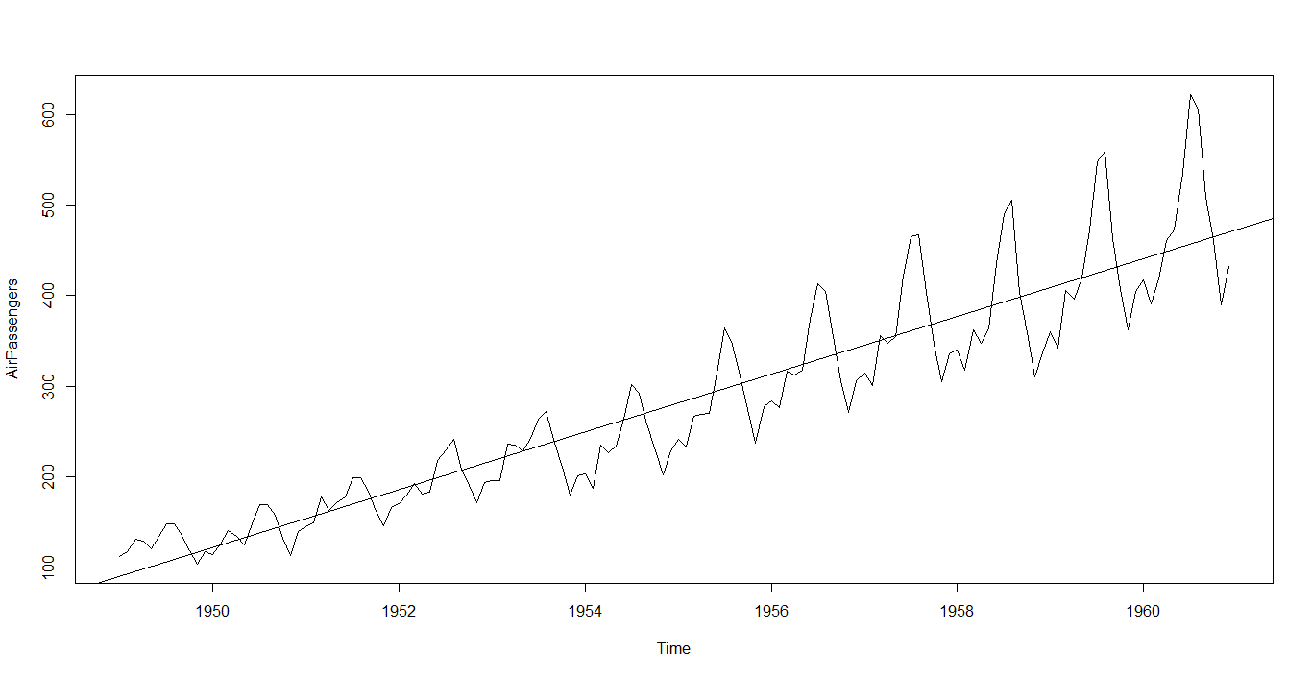
Interpretation:
. 1) The Year on year trend clearly shows that the number passengers have been increasing .
- The variance and mean value in July and August is much higher than rest of months.
To remove unequal variance ,we use log –transformation on Airpassengers data.
3) There must be second effect with cycle of 12 months.
b) Decompose seasonal data

A seasonal time series consists of a trend component, a seasonal component and an irregular component. Decomposing the time series means separating the time series into these three components: that is, estimating these three components.

> AP.decompM=decompose(AirPassengers, type ="multiplicative")
> plot(AP.decompM)
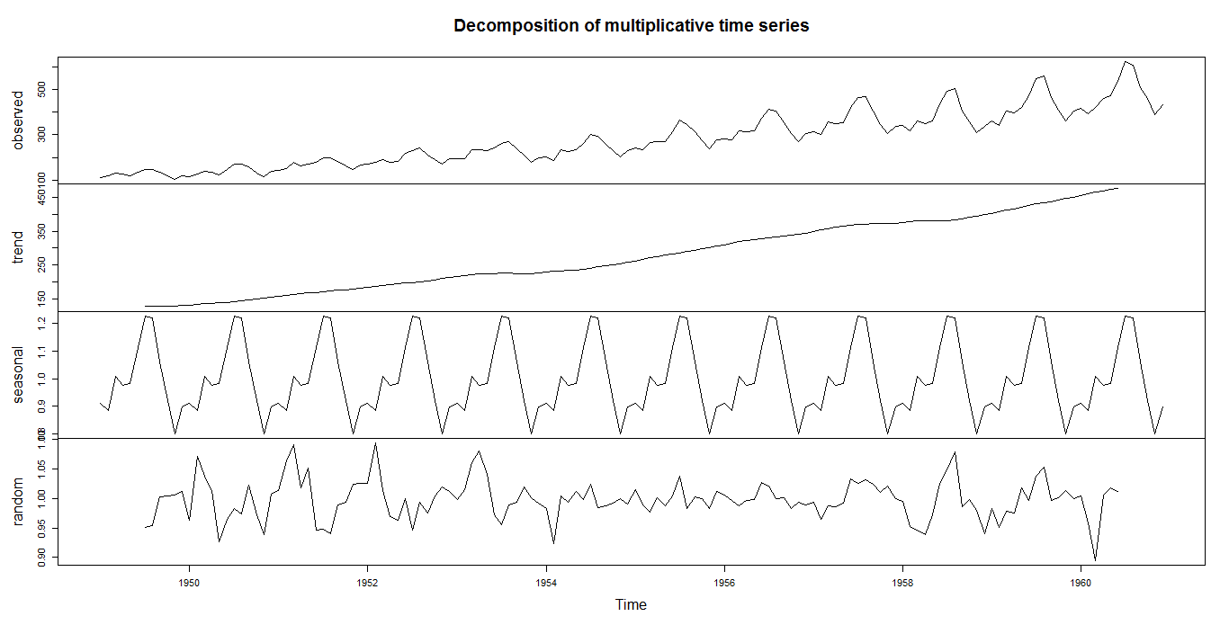
Interpretations:
The above figure shows the time series decomposition into trend, seasonal and random (noise).It is clear that the time series is non-stationary (has random walks) because of seasonal effects and a trend (linear trend).
- Stationary the Series :
Our next test to test given series is stationary or not for this we use Augmented Dickey Fuller test the hypothesis of test
H_{o} : Unit root present in time series sample i.e. non-stationary. V/s
H₁: Time series sample is stationary.
> adf.test(log(AirPassengers), alternative="stationary",k=12)
Augmented Dickey-Fuller Test

data: log(AirPassengers)
Dickey-Fuller = -1.5325, Lag order = 12, p-value = 0.7711
alternative hypothesis: stationary
Conclusion: As observed p-value of given test is greater than 5% l.o.s, so we fail to reject H₀. Hence given series is non-stationary.
To make it stationary we have considered first order difference on Air passenger data. Then performed Augmented Dickey Fuller test .
> adf.test(diff(log(AirPassengers)),alternative="stationary", k=12)

Augmented Dickey-Fuller Test

data: diff(log(AirPassengers))
Dickey-Fuller = -16.569, Lag order = 12, p-value = 0.01
alternative hypothesis: stationary
As observed p-value of given test is less than 5% l.o.s, so we reject H₀. Hence given series is stationary.
The next step of analysis is to find optimal ARIMA Model through ACF and PACF.

- Plot ACF/PACF and find optimal parameter

- Corregram of Log transform data
- > acf(log(AirPassengers))

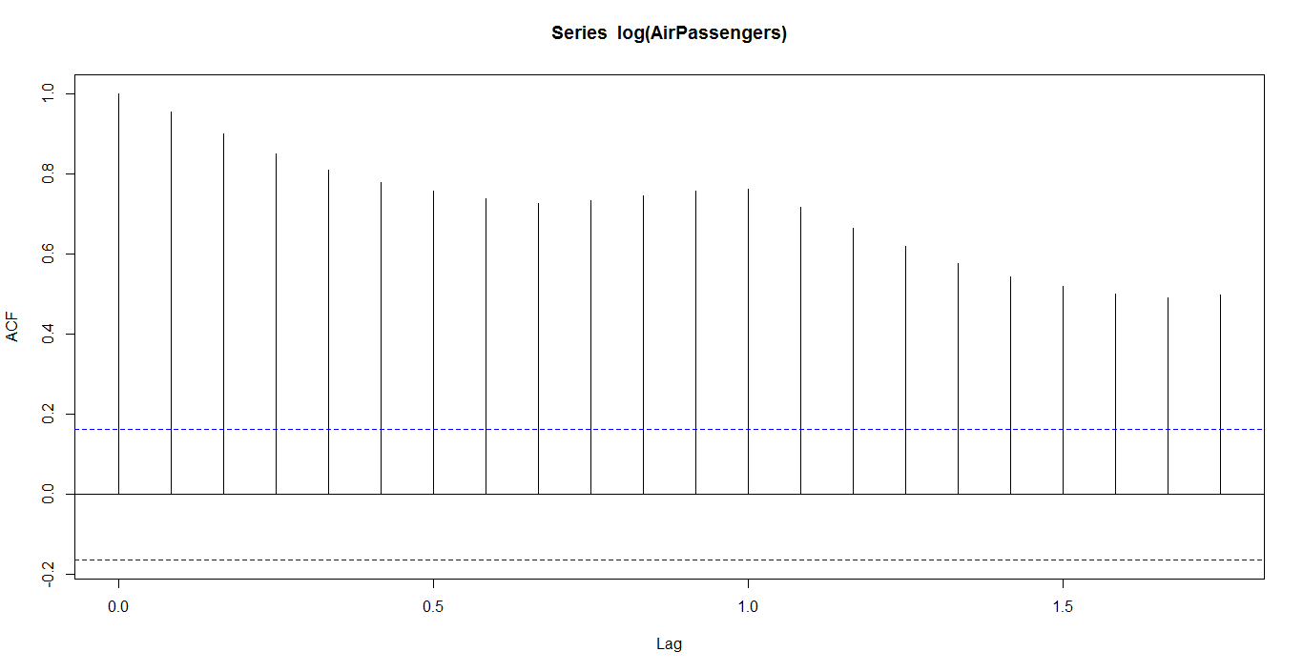
Conclusion:
Decay is very slow, so non-stationary.
Hence we use first order difference of lag.
Corregram and partial Corregram of difference log transformed data:
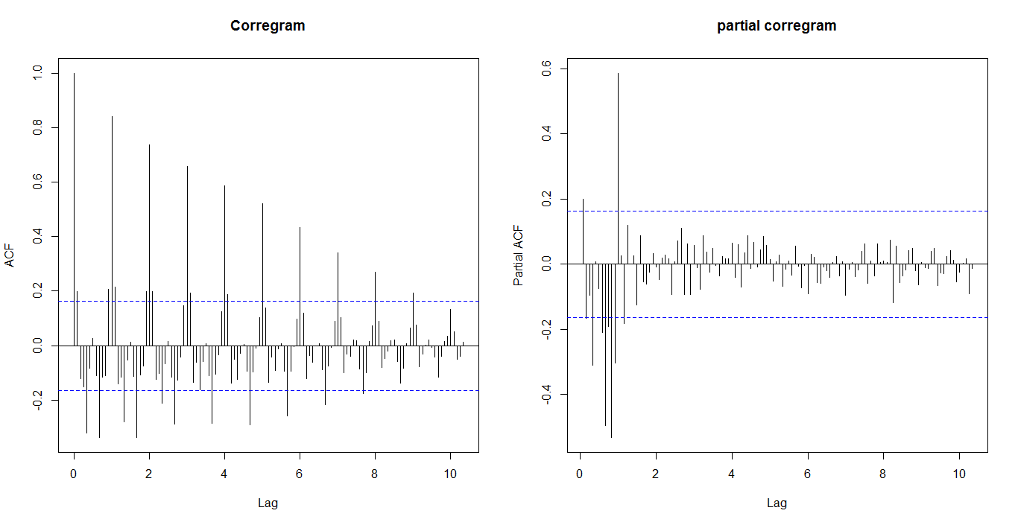

We have considered first order difference to remove trend and seasonality. Hence d=1,D=1
we examine at Lag 0,12,24,…
We have seen from the correlogram that the autocorrelation at lag 1,2, exceed the significance bound.
The partial correlogram shows that the partial autocorrelations at lags1,exceed the significance bounds,
The partial autocorrelations tail off to zero after lag 1.
Similarly we examine between seasonal lag 1,2,1…12. And we get ,
We see from the correlogram that the autocorrelation at lag 1,2 ,exceed the significance bound.
The partial correlogram shows that the partial autocorrelations at lags1,exceed the significance bounds,
The partial autocorrelations tail off to zero after lag 1.
We use the principle of parsimony to decide which model is best: that is, we assume that the model with the fewest parameters is best. Hence ARIMA(0,1,1)X(0,1,1)₁₂ is best model

- Modeling the volatility:
Our next aim is to test does there any arch/garch effect or not for this we use Ljung–Box test

The test hypothesis for :Ljung-Box test:
i.e. series is suffered from arch/garch effect .
v/s
i.e. there is an arch/garch effect
Where:
- is the null hypothesis.
- is the alternate hypothesis.
- is the population autocorrelation function for the squared time series (i.e. ).
- is the maximum number of lags included in the ARCH effect test.

> Box.test(fit$residuals^2,lag=12,type="Ljung-Box")

Box-Ljung test

data: fit$residuals^2
X-squared = 17.074, df = 12, p-value = 0.1469
Conclusion: As observed p-value of given test is greater than 5% l.o.s, so we fail to reject H₀. Hence there is no arch/garch effect.
Next step of Analysis is forecasting.
- Forecasting
Then we fit the SARIMA prediction model.
> fit=arima(log(AirPassengers), c(0, 1, 1),seasonal = list(order = c(0, 1, 1), period = 12))
> fit

Call:
arima(x = log(AirPassengers), order = c(0, 1, 1), seasonal = list(order = c(0,
1, 1), period = 12))

Coefficients:
ma1 sma1
-0.4018 -0.5569
s.e. 0.0896 0.0731

sigma^2 estimated as 0.001348: log likelihood = 244.7, aic = -483.4

Then 95% 95% C.I. for each prediction value is obtain and plot with observed value as fallow
> fore=predict(fit, n.ahead = 10*12)
> U=fore$pred + 2*fore$se # se: standard error (quantile is 2 as mean=0)
> L=fore$pred - 2*fore$se
> head(cbind(U,L))
U L
Jan 1961 6.183617 6.036754
Feb 1961 6.139341 5.968209
Mar 1961 6.267896 6.075533
Apr 1961 6.305037 6.093564
May 1961 6.347053 6.118059
Jun 1961 6.491412 6.246145

> # plot observed and predicted values
> ts.plot(AirPassengers,2.718^fore$pred,2.718^U,2.718^L,log = "y", lty = c(1,1,2,2),col=c(1, 2, 4, 4))
> legend("topleft", c("Actual", "Forecast", "Error Bounds (95% prediction interval)"), col=c(1, 2, 4),lty=c(1, 1, 2),bty = "n")
>

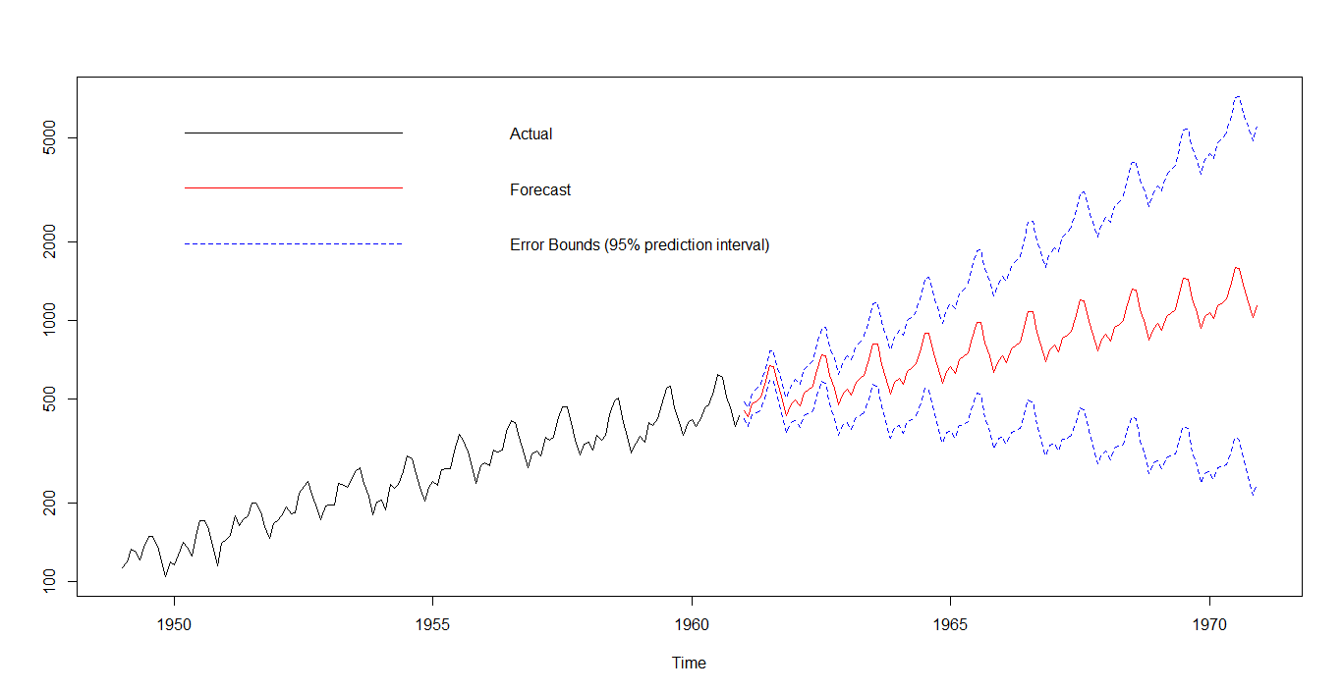

Last but not least step of analysis is assumption testing and cross verification.
- assumption testing and cross verification.
- Normality Testing
ARIMA fit the model using maximum likelihood estimation (assuming Gaussian residual).To check this assumption we use Q-Q plot.
> qqnorm(residuals(fit))
> qqline(residuals(fit))
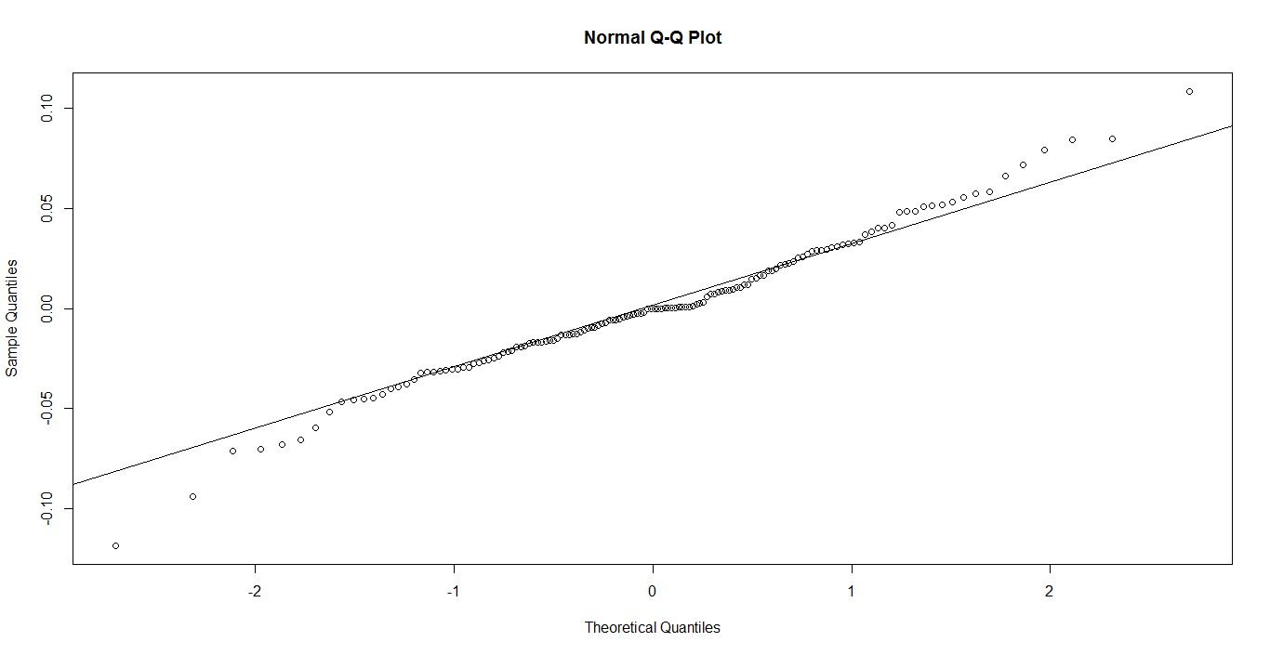
Conclusion: Linearity of point suggests that the distribution is normally distributed.
> shapiro.test(residuals(fit))

Shapiro-Wilk normality test

data: residuals(fit)
W = 0.98637, p-value = 0.1674
- Verifications of stationary
To cross check the stationary .we use Augmented Dickey-Fuller test.
> adf.test(residuals(fit), alternative="stationary", k=12)

Augmented Dickey-Fuller Test

data: residuals(fit)
Dickey-Fuller = -3.7242, Lag order = 12, p-value = 0.02472
alternative hypothesis: stationary

Conclusion: Residuals are stationary.

Data set No. 2
Data description :
We have consider data from
http://data.worldbank.org/indicator/NY.GDP.PCAP.KD.ZG . This data contain year wise World Development Indicator(WDI) of India from 1960 to 2015.
> x1=read.table("C:\\Users\\Ram dhadage\\Desktop\\time seies datasets\\WDI_india.txt",sep="\t",header=T)
> d1=x1[,2]
> dim(x1)
[1] 55 2
> d1=ts(d1,end=c(2016))
> summary(d1)
Min. 1st Qu. Median Mean 3rd Qu. Max.
-5.238 3.812 5.713 5.287 7.501 10.260
We have considered following step for analysis.
- Visualize the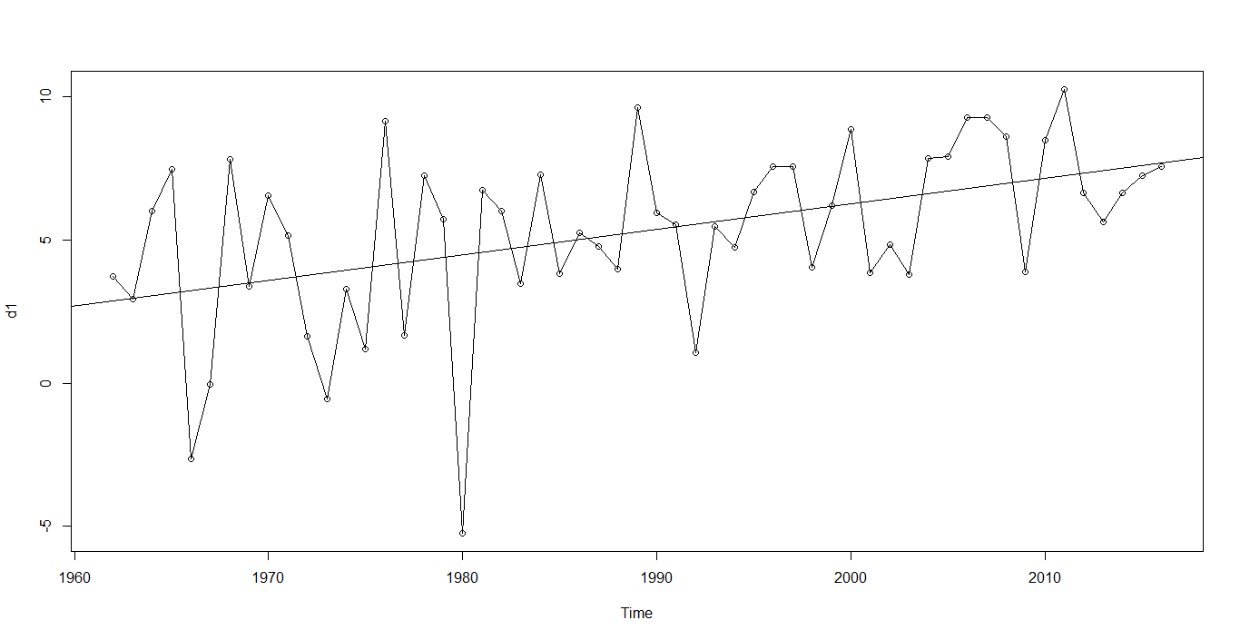 time series :
a)Time series plot:
> plot.ts(d1,type="o");abline(reg=lm(d1~time(d1)))
Interpretation:
.1) The Year on year trend clearly shows that the WDI have been increasing.
- Time series plot doesn’t show seasonality pattern.

- We can see from the time plot that this time series could probably be described using an additive model, since the random fluctuations in the data are roughly constant in size over time.
- Forecasting
For short time forecast we can use exponential smoothing
> forecast=HoltWinters(d1,beta=FALSE,gamma=FALSE)
> forecast
Call:
HoltWinters(x = d1, beta = FALSE, gamma = FALSE)

Smoothing parameters:
alpha: 0.1048479
beta : FALSE
gamma: FALSE

Coefficients:
[,1]
a 6.932848
The output of HoltWinters() tells us that the estimated value of the alpha parameter is about 0.104879. This is very
close to zero, telling us that the forecasts are based on both recent and less recent observations (although somewhat
more weight is placed on recent observations).
By default, HoltWinters() just makes forecasts for the same time period covered by our original time series.
> plot(forecast)

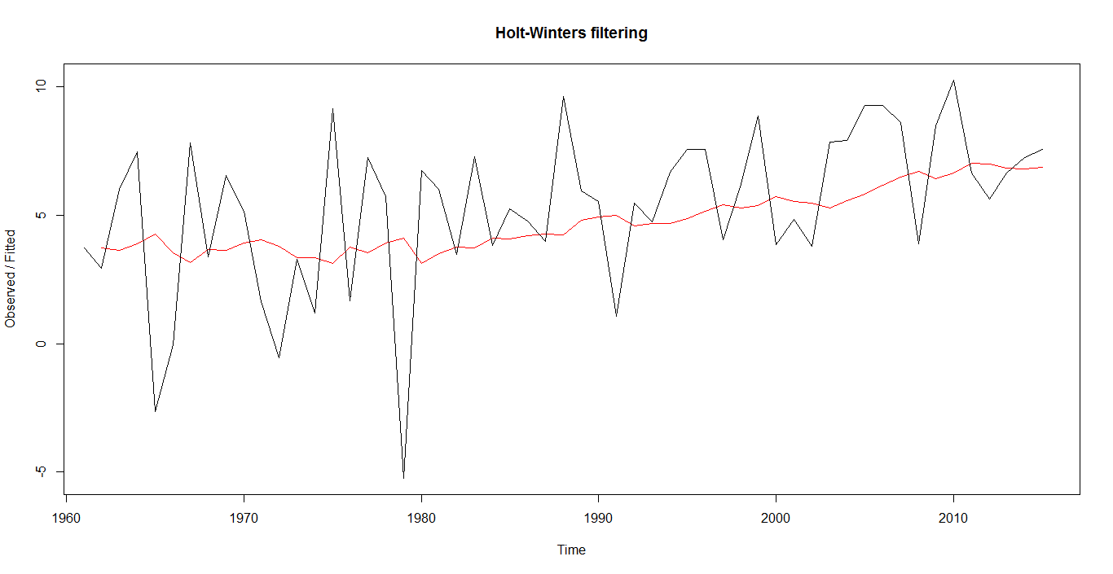

This is plot of original series and forecast series. Where red color shows forecasted series and black shows original series.
To check accuracy of forecasting we can sum of square of sample error.
> forecast$SSE
[1] 471.73

We have forecast feather WDI from original series and plotted with original series as fallow

> plot.forecast(forecast.HoltWinters(forecast,h= 55),shadecols=c(4,3))
> legend("topleft", c("Actual", "Forecast", "Error Bounds (95% prediction interval)","Error Bounds (80% prediction interval)"), fill=c(1, 2, 4,3),cex=0.50,lty=c(1, 1, 2,3),bty = "n")
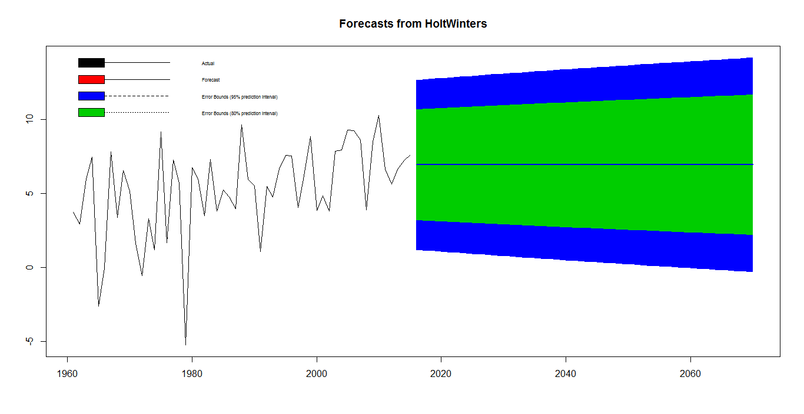

- Modeling of volatility
Our next aim is to test does there any arch/garch effect or not for this we use Ljung–Box test

The test hypothesis for :Ljung-Box test:
i.e. series is suffered from arch/garch effect .
v/s
i.e. there is an arch/garch effect
Where:
- is the null hypothesis.
- is the alternate hypothesis.
- is the population autocorrelation function for the squared time series (i.e. ).
- is the maximum number of lags included in the ARCH effect test.

>Box.test(forecast.HoltWinters(forecast,h= 55)$residuals^2,type="Ljung-Box")

Box-Ljung test

data: forecast.HoltWinters(forecast, h = 55)$residuals^2
X-squared = 0.0019258, df = 1, p-value = 0.965

Conclusion: As observed p-value of given test is greater than 5% l.o.s, so we fail to reject H₀. Hence there is no arch/garch effect.
Next step of Analysis is forecasting.

- Assumption testing
We want to check weather residual fallow normality or not

> plotForecastErrors=function(forecasterrors)
+ {
+ mybinsize=IQR(forecasterrors)/4
+ mysd =sd(forecasterrors)
+ mymin= min(forecasterrors) - mysd*5
+ mymax = max(forecasterrors) + mysd*3
+ mynorm = rnorm(10000, mean=0, sd=mysd)
+ mymin2 = min(mynorm)
+ mymax2 = max(mynorm)
+ if (mymin2 < mymin) { mymin = mymin2 }
+ if (mymax2 > mymax) { mymax = mymax2 }
+ mybins = seq(mymin, mymax, mybinsize)
+ hist(forecasterrors, col="red", freq=FALSE, breaks=mybins)
+ myhist=hist(mynorm, plot=FALSE, breaks=mybins)
+ points(myhist$mids, myhist$density, type="l", col="blue", lwd=2)
+ }
> plotForecastErrors(fore$residuals[-1])
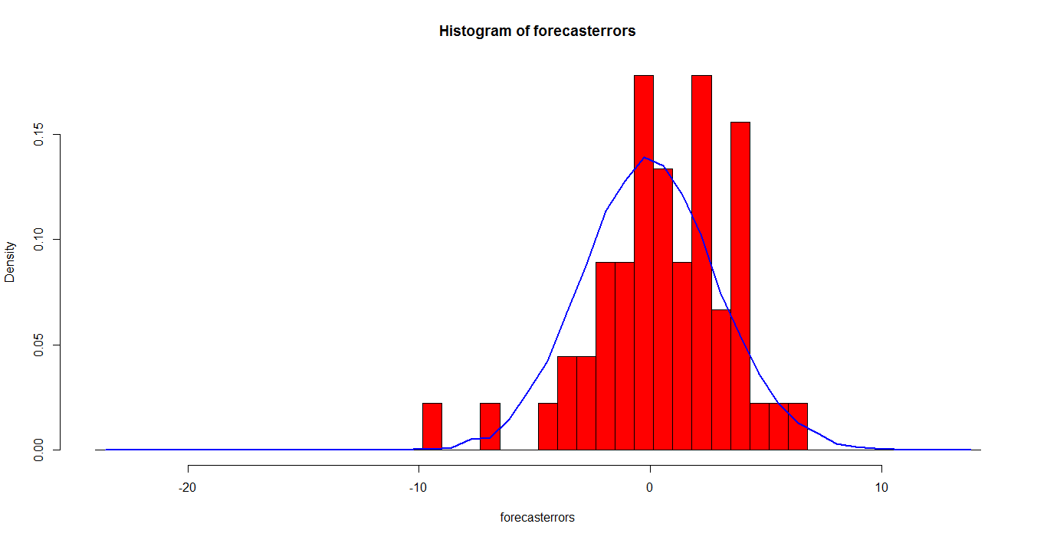

The plot shows that the distribution of forecast errors is roughly centered on zero, and is more or less normally distributed, although it seems to be slightly skewed to the right compared to a normal curve. However, the right skew is relatively small, and so it is plausible that the forecast errors are normally distributed with mean zero. The Ljung-Box test showed that there is little evidence of non-zero autocorrelations in the in-sample forecasterrors, and the distribution of forecast errors seems to be normally distributed with mean zero. This suggests that the simple exponential smoothing method provides an adequate predictive model for London rainfall, which probably cannot be improved upon. Furthermore, the assumptions that the 80% and 95% predictions intervals were based upon (that there are no autocorrelations in the forecast errors, and the forecast errors are normally distributed with mean zero and constant variance) are probably valid.

Data set 3

Data description:
We have consider data from http://www.bseindia.com/markets/equity/EQReports/StockPrcHistori.aspx?expandable=7&flag=0
This data contain year wise turnover of Bajaj finance Company.
> x1=read.table("C:\\Users\\Ram dhadage\\Desktop\\time seies datasets\\data_set_1.txt",sep="\t",header=T)
> d1=x1[,2]
> d1=ts(d1,end=c(2016))
> summary(d1)
Min. 1st Qu. Median Mean 3rd Qu. Max.
5.534e+05 1.376e+08 1.046e+09 2.902e+09 2.732e+09 2.296e+10
We have considered following step for analysis.
- Visualize the time series :
a)Time series plot:
> plot.ts(d1,type="o");abline(reg=lm(d1~time(d1)))

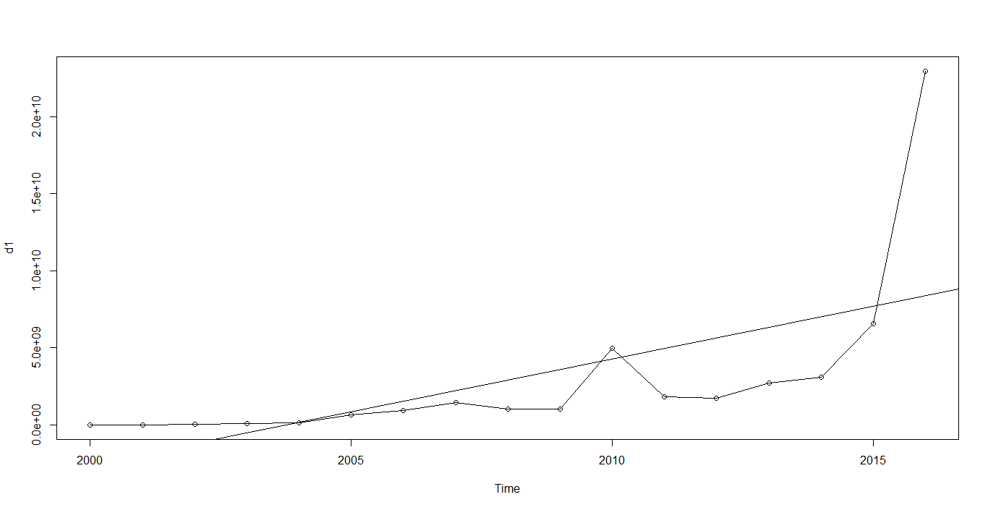

Interpretation:
.1) The Year on year trend clearly shows that the turnover of Bajaj finance company have been increasing.
- Time series plot doesn’t show seasonality pattern.

- We can see from the time plot that this time series could probably be described using an additive model, since the random fluctuations in the data are roughly constant in size over time.
- To remove unequal variance ,we use log –transformation
- Forecasting
For short time forecast we can use exponential smoothing
> forecast=HoltWinters(log(d1),beta=FALSE,gamma=FALSE)
> forecast
Holt-Winters exponential smoothing without trend and without seasonal component.

Call:
HoltWinters(x = log(d1), beta = FALSE, gamma = FALSE)

Smoothing parameters:
alpha: 0.9999197
beta : FALSE
gamma: FALSE

Coefficients:
[,1]
a 23.85677
>

The output of HoltWinters() tells us that the estimated value of the alpha parameter is about 0.9999339. This is very
close to one, telling us that the forecasts are based on both recent and less recent observations (although somewhat
more weight is placed on recent observations).
By default, HoltWinters() just makes forecasts for the same time period covered by our original time series.

> plot(forecast)

> 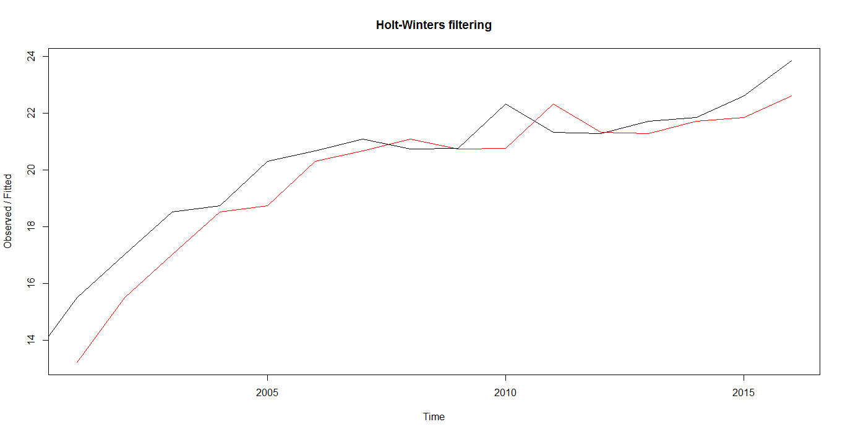
This is plot of original series and forecast series. Where red color shows forecasted series and black shows original series.
To check accuracy of forecasting we can sum of square of sample error.
> forecast$SSE
[1] 18.56074
We have forecast feather year wise turnover of Bajaj finance company from original series and plotted with
original series as fallow

> t1=forecast.HoltWinters(forecast,h= 17)
> plot.forecast(forecast.HoltWinters(forecast,h= 17),shadecols=c(4,3))
> legend("topleft", c("Actual", "Forecast", "Error Bounds (95% prediction interval)","Error Bounds (80% prediction interval)"), fill=c(1, 2, 4,3),cex=0.50,lty=c(1, 1, 2,3),bty = "n")
>

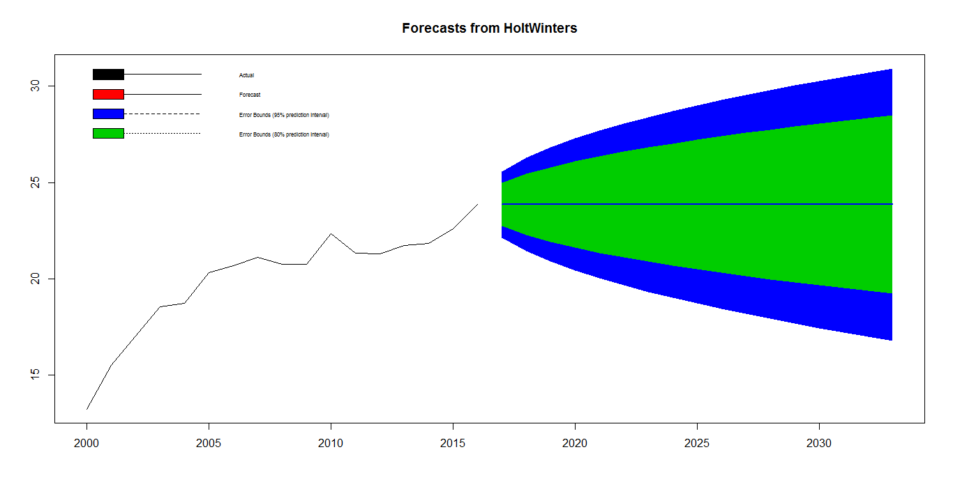
- Modeling of volatility
Our next aim is to test does there any arch/garch effect or not for this we use Ljung–Box test

The test hypothesis for :Ljung-Box test:
i.e. series is suffered from arch/garch effect .
v/s
i.e. there is an arch/garch effect
Where:
- is the null hypothesis.
- is the alternate hypothesis.
- is the population autocorrelation function for the squared time series (i.e. ).
- is the maximum number of lags included in the ARCH effect test.

> Box.test(forecast.HoltWinters(forecast,h= 17)$residuals^2,type="Ljung-Box")

Box-Ljung test

data: forecast.HoltWinters(forecast, h = 17)$residuals^2
X-squared = 0.76224, df = 1, p-value = 0.3826

Conclusion: As observed p-value of given test is greater than 5% l.o.s, so we fail to reject H₀. Hence there is no arch/garch effect.
Next step of Analysis is forecasting.

- Assumption testing
We want to check weather residual fallow normality or not

> plotForecastErrors=function(forecasterrors)
+ {
+ mybinsize=IQR(forecasterrors)/4
+ mysd =sd(forecasterrors)
+ mymin= min(forecasterrors) - mysd*5
+ mymax = max(forecasterrors) + mysd*3
+ mynorm = rnorm(10000, mean=0, sd=mysd)
+ mymin2 = min(mynorm)
+ mymax2 = max(mynorm)
+ if (mymin2 < mymin) { mymin = mymin2 }
+ if (mymax2 > mymax) { mymax = mymax2 }
+ mybins = seq(mymin, mymax, mybinsize)
+ hist(forecasterrors, col="red", freq=FALSE, breaks=mybins)
+ myhist=hist(mynorm, plot=FALSE, breaks=mybins)
+ points(myhist$mids, myhist$density, type="l", col="blue", lwd=2)
+ }
> plotForecastErrors(fore$residuals[-1])
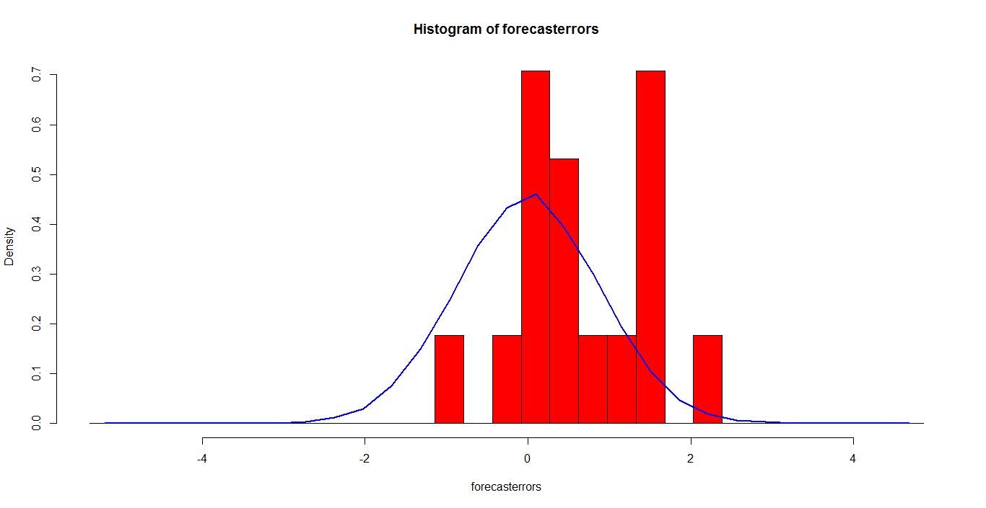

The plot shows that the distribution of forecast errors is centered on zero, and is normally distributed.
. The Ljung-Box test showed that there is little evidence of non-zero autocorrelations in the in-sample forecasterrors, and
the distribution of forecast errors seems to be normally distributed with mean zero. This suggests that the simple
exponential smoothing method provides an adequate predictive model for London rainfall, which probably cannot be
improved upon. Furthermore, the assumptions that the 80% and 95% predictions intervals were based upon (that there
are no autocorrelations in the forecast errors, and the forecast errors are normally distributed with mean zero and
constant variance) are probably valid.

Data set No.4
Data description:
I have considered a data set ldeaths which is contained in R directories. Data set gives the monthly deaths from
bronchitis, emphysema and asthma in the UK, 1974–1979, both sexes.
> ldeaths
Jan Feb Mar Apr May Jun Jul Aug Sep Oct Nov Dec
1974 3035 2552 2704 2554 2014 1655 1721 1524 1596 2074 2199 2512
1975 2933 2889 2938 2497 1870 1726 1607 1545 1396 1787 2076 2837
1976 2787 3891 3179 2011 1636 1580 1489 1300 1356 1653 2013 2823
1977 3102 2294 2385 2444 1748 1554 1498 1361 1346 1564 1640 2293
1978 2815 3137 2679 1969 1870 1633 1529 1366 1357 1570 1535 2491
1979 3084 2605 2573 2143 1693 1504 1461 1354 1333 1492 1781 1915
> summary(ldeaths)
Min. 1st Qu. Median Mean 3rd Qu. Max.
1300 1552 1870 2057 2552 3891

We have considered following step for analysis.
- Visualize the time series :
a)Time series plot:

> plot(ldeaths);abline(reg=lm(ldeaths~time(ldeaths)))

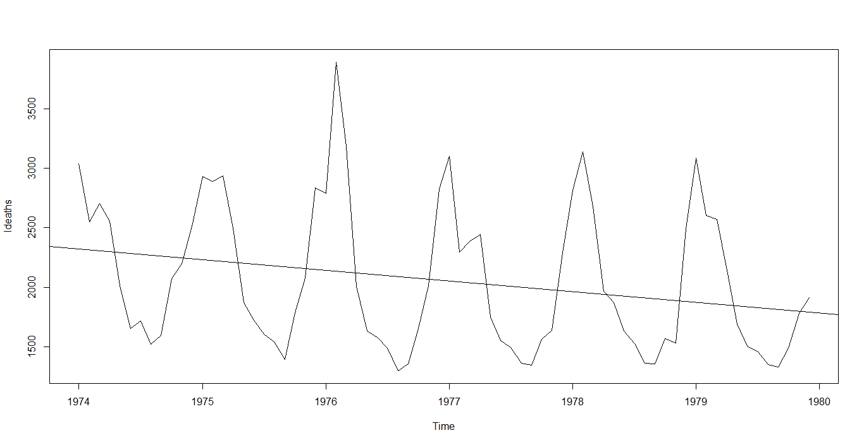
> boxplot(ldeaths~cycle(ldeaths))
> 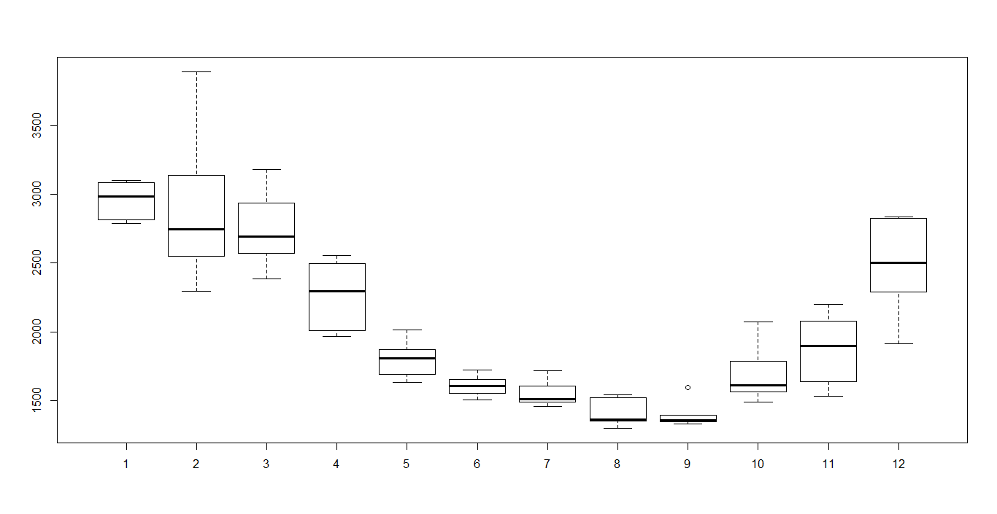

Interpretation:
. 1) The Year on year trend clearly shows that the number deaths have been
decreasing .
- The variance and mean value in February and December is much higher than rest of
months.
To remove unequal variance ,we use log –transformation on ldeaths.
3) There must be seasonal effect with cycle of 12 months.

b) Decompose seasonal data
A seasonal time series consists of a trend component, a seasonal component and an irregular component. Decomposing the time series means separating the time series into these three components: that is, estimating these three components.
> AP.decompM=decompose(ldeaths, type = "multiplicative")
> plot(AP.decompM)
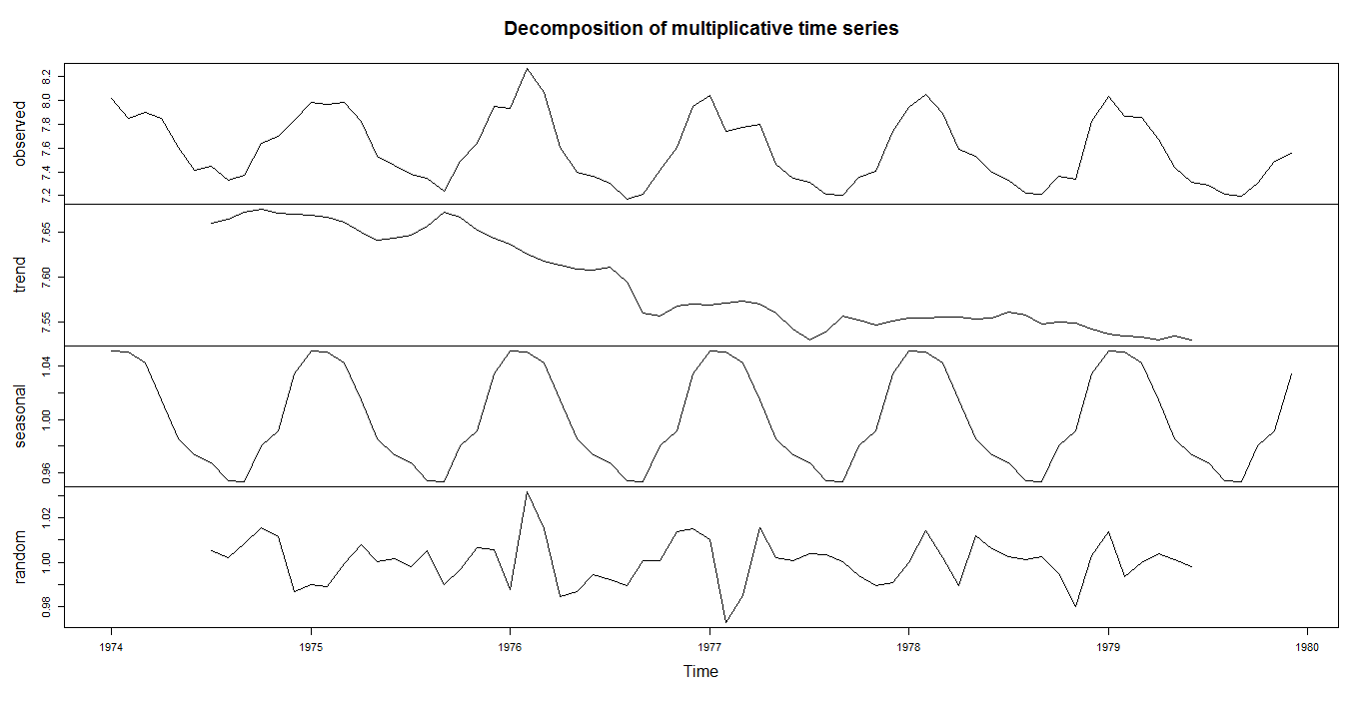

Interpretations:
The above figure shows the time series decomposition into trend, seasonal and random (noise) . It is clear that the time series is non-stationary (has random walks) because of seasonal effects and a trend (linear trend).
- Stationary the Series :
Our next test to test given series is stationary or not for this we use Augmented Dickey Fuller test the hypothesis of test

H_{o} : Unit root present in time series sample i.e. non-stationary. V/s
H₁: Time series sample is stationary.
> adf.test(log(ldeaths), alternative="stationary", k=12)

Augmented Dickey-Fuller Test

data: log(ldeaths)
Dickey-Fuller = -2.0091, Lag order = 12, p-value = 0.5716
alternative hypothesis: stationary
Conclusion: As observed p-value of given test is greater than 5% l.o.s, so we fail to reject H₀. Hence given series is non-stationary. To make it stationary we have considered first order difference on Air passenger data. Then performed Augmented Dickey Fuller test .

> adf.test(diff(log(ldeaths)), alternative="stationary", k=12)

Augmented Dickey-Fuller Test

data: diff(log(ldeaths))
Dickey-Fuller = -5.4058, Lag order = 12, p-value = 0.01
alternative hypothesis: stationary
As observed p-value of given test is less than 5% l.o.s, so we reject H₀. Hence given series is stationary.
The next step of analysis is to find optimal ARIMA Model through ACF and PACF.

- Plot ACF/PACF and find optimal parameter
- Corregram of Log transform data

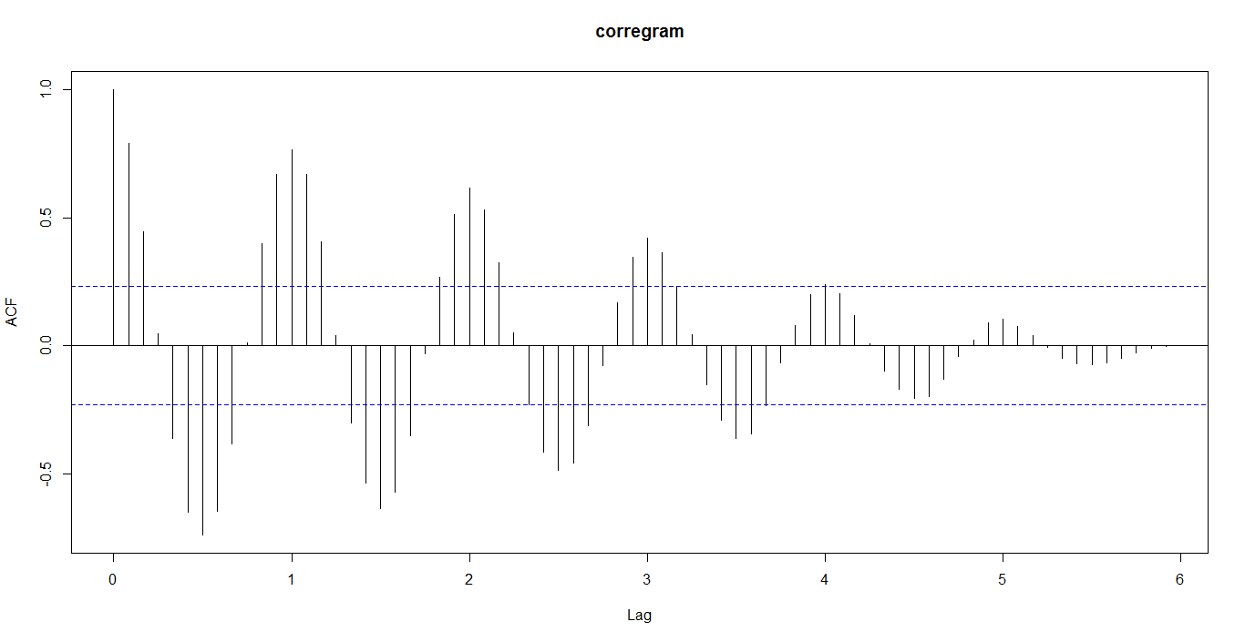

Decay is very slow, so non-stationary.
Hence we use first order difference of lag.
Corregram and partial Corregram of difference log transformed data:
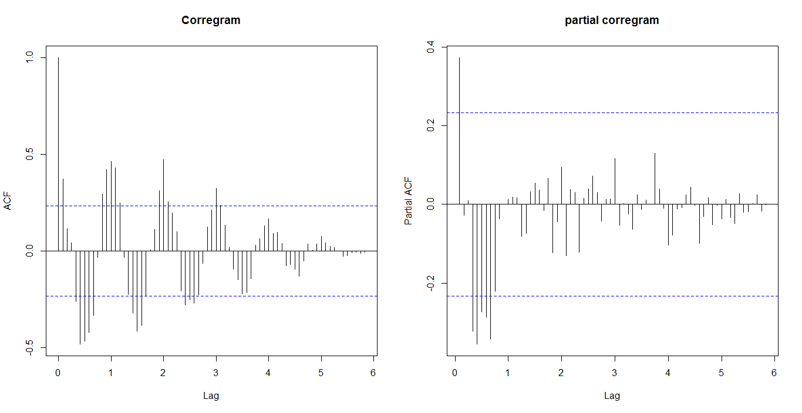

We have considered first order difference to remove trend and seasonality. Hence d=1,D=1
we examine at Lag 0,12,24,…
We have seen from the correlogram that the autocorrelation at lag 1,2, exceed the significance bound.
The partial correlogram shows that the partial autocorrelations at lags1,exceed the significance bounds,
The partial autocorrelations tail off to zero after lag 1.
Similarly we examine between seasonal lag 1,2,1…12. And we get ,
We see from the correlogram that the autocorrelation at lag 1,2 ,exceed the significance bound.
The partial correlogram shows that the partial autocorrelations at lags1,exceed the significance bounds,
The partial autocorrelations tail off to zero after lag 1.
We use the principle of parsimony to decide which model is best: that is, we assume that the model with the fewest parameters is best. Hence ARIMA(0,1,1)X(0,1,1)₁₂ is best model
- Modeling the volatility:
Our next aim is to test does there any arch/garch effect or not for this we use Ljung–Box test

The test hypothesis for :Ljung-Box test:
i.e. series is suffered from arch/garch effect .
v/s
i.e. there is an arch/garch effect
Where:
- is the null hypothesis.
- is the alternate hypothesis.
- is the population autocorrelation function for the squared time series (i.e. ).
- is the maximum number of lags included in the ARCH effect test.

> Box.test(fit$residuals^2,lag=12,type="Ljung-Box")

Box-Ljung test

data: fit$residuals^2
X-squared = 14.292, df = 12, p-value = 0.2824

Conclusion: As observed p-value of given test is greater than 5% l.o.s, so we fail to reject H₀. Hence there is no arch/garch effect.
Next step of Analysis is forecasting.
- Forecasting
Then we fit the SARIMA prediction model.

> fit=arima(log(ldeaths), c(0, 1, 1),seasonal = list(order = c(0, 1, 1), period = 12))
> fit

Call:
arima(x = log(ldeaths), order = c(0, 1, 1), seasonal = list(order = c(0, 1,
1), period = 12))

Coefficients:
ma1 sma1
-0.9999 -0.9998
s.e. 0.1038 0.4532

sigma^2 estimated as 0.000139: log likelihood = 164.86, aic = -323.73
Then 95% C.I. for each prediction value is obtain and plot with observed value as fallow
> fore=predict(fit, n.ahead = 10*12)
> U=fore$pred + 2*fore$se # se: standard error (quantile is 2 as mean=0)
> L=fore$pred - 2*fore$se
> head(cbind(U,L))
U L
[1,] 2.090283 2.038101
[2,] 2.085535 2.033352
[3,] 2.080260 2.028077
[4,] 2.055843 2.003660
[5,] 2.026199 1.974016
[6,] 2.010925 1.958742
> # plot observed and predicted values
> ts.plot(ldeaths,2.718^fore$pred,2.718^U,2.718^L,log = "y", lty = c(1,1,2,2),col=c(1, 2, 4, 4))
> legend("topleft", c("Actual", "Forecast", "Error Bounds (95% prediction interval)"), col=c(1, 2, 4),lty=c(1, 1, 2),bty = "n")

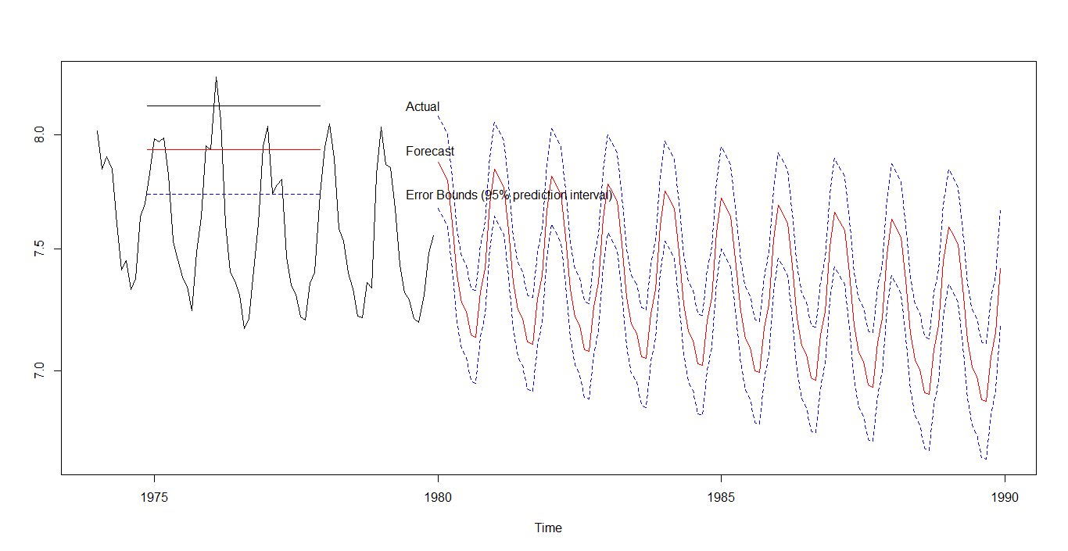

Last but not least step of analysis is assumption testing and cross verification.
- assumption testing and cross verification.
- Normality Testing
ARIMA fit the model using maximum likelihood estimation (assuming Gaussian residual).To check this assumption we use Q-Q plot.
> qqnorm(residuals(fit))
> qqline(residuals(fit))

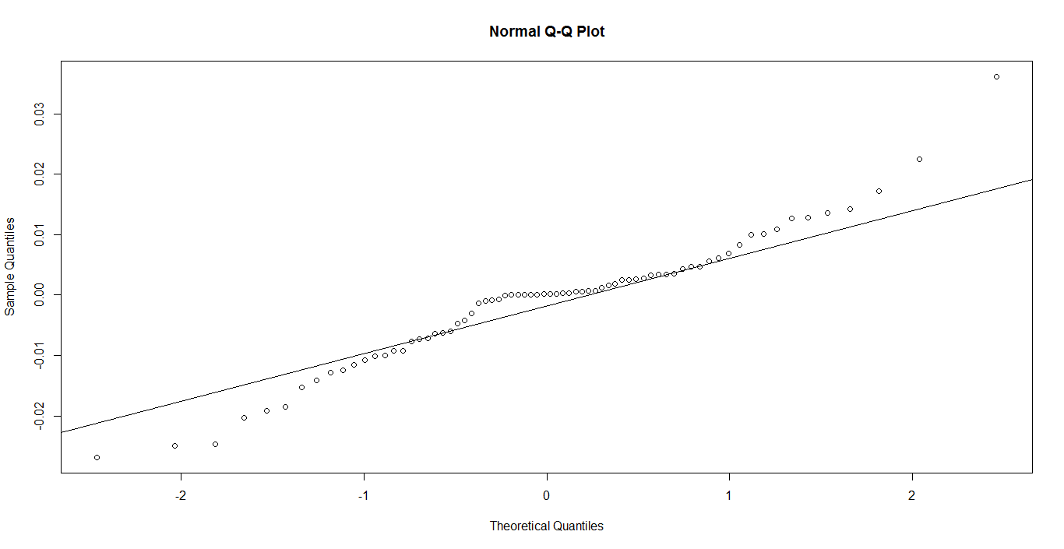

Conclusion: Linearity of point suggests that the distribution is normally distributed.

> shapiro.test(residuals(fit))

Shapiro-Wilk normality test

data: residuals(fit)
W = 0.95809, p-value = 0.0672
- Verifications of stationary
To cross check the stationary .we use Augmented Dickey-Fuller test.
> adf.test(residuals(fit), alternative="stationary", k=12)

Augmented Dickey-Fuller Test

data: residuals(fit)
Dickey-Fuller = -1.9102, Lag order = 12, p-value = 0.0111
alternative hypothesis: stationary
Conclusion: Residuals are stationary.

Data set No-5
Data Description:
I have considered a data set UKDriverDeaths which is contained in R directories. UKDriverDeaths is a time series giving the monthly totals of car drivers in Great Britain killed or seriously injured Jan 1969 to Dec 1984. Compulsory wearing of seat belts was introduced on 31 Jan 1983
> data(UKDriverDeaths)
> summary(UKDriverDeaths)
Min. 1st Qu. Median Mean 3rd Qu. Max.
1057 1462 1631 1670 1851 2654

We have considered following step for analysis.
- Visualize the time series :
a)Time series plot:
> plot(UKDriverDeaths);abline(reg=lm(UKDriverDeaths~time(UKDriverDeaths)))
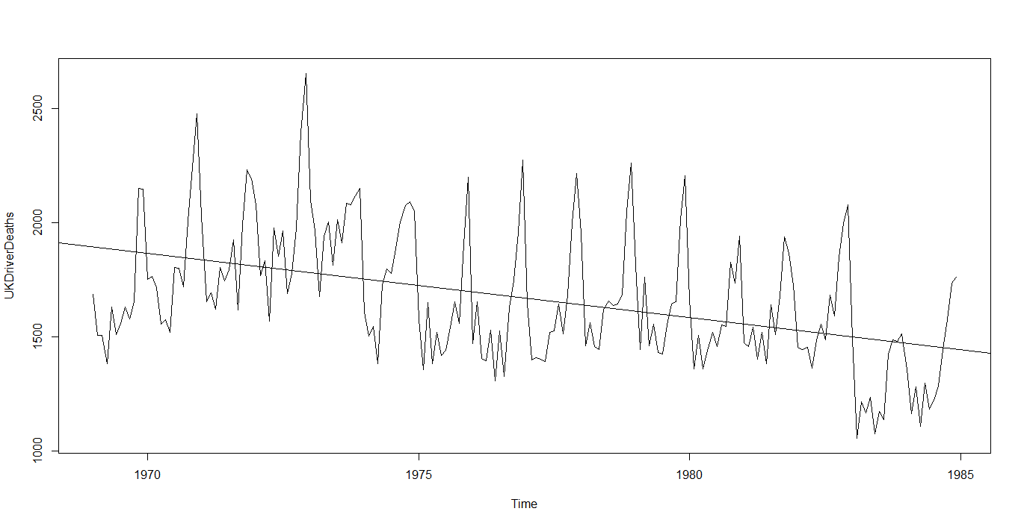

> boxplot(UKDriverDeaths~cycle(UKDriverDeaths))
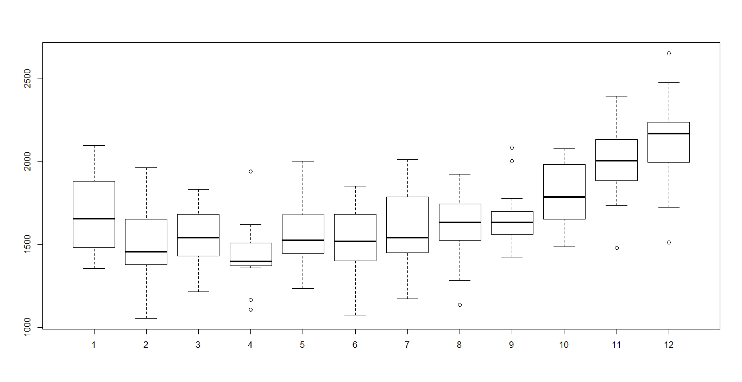

Interpretation:
. 1) The Year on year trend clearly shows that the number deaths have been decreasing.
- The variance and mean value in January, July and August is much higher than rest of months.
To remove unequal variance ,we use log –transformation
3) There must be seasonal effect with cycle of 12 months.
b) Decompose seasonal data
A seasonal time series consists of a trend component, a seasonal component and an irregular component. Decomposing the time series means separating the time series into these three components: that is, estimating these three components.

> AP.decompM=decompose(UKDriverDeaths, type = "multiplicative")
> plot(AP.decompM)
> 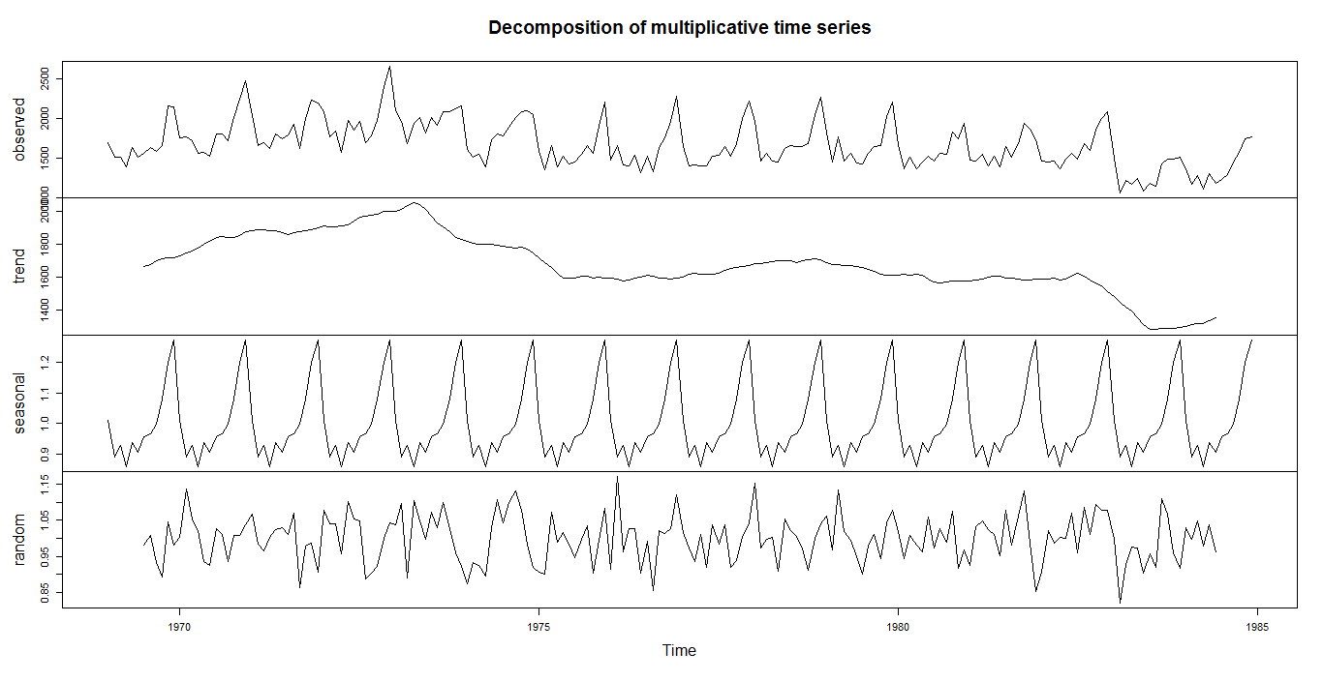

Interpretations:
The above figure shows the time series decomposition into trend, seasonal and random (noise) . It is clear that the time series is non-stationary (has random walks) because of seasonal effects and a trend (linear trend).
- Stationary the Series :
Our next test to test given series is stationary or not for this we use Augmented Dickey Fuller test the hypothesis of test

H_{o} : Unit root present in time series sample i.e. non-stationary. V/s
H₁: Time series sample is stationary.
> adf.test(log(UKDriverDeaths), alternative="stationary", k=12)

Augmented Dickey-Fuller Test

data: log(UKDriverDeaths)
Dickey-Fuller = -2.4949, Lag order = 12, p-value = 0.3691
alternative hypothesis: stationary
Conclusion: As observed p-value of given test is greater than 5% l.o.s, so we fail to reject H₀. Hence given series is non-stationary.
To make it stationary we have considered first order difference on Air passenger data. Then performed Augmented Dickey Fuller test .
> adf.test(diff(log(UKDriverDeaths)), alternative="stationary", k=10)

Augmented Dickey-Fuller Test

data: diff(log(UKDriverDeaths))
Dickey-Fuller = -12.804, Lag order = 10, p-value = 0.01
alternative hypothesis: stationary

Warning message:
In adf.test(diff(log(UKDriverDeaths)), alternative = "stationary", :
p-value smaller than printed p-value
As observed p-value of given test is less than 5% l.o.s, so we reject H₀. Hence given series is stationary.
The next step of analysis is to find optimal ARIMA Model through ACF and PACF.

- Plot ACF/PACF and find optimal parameter
> acf(log(UKDriverDeaths),lag.max=124,main="corregram")

a)Corregram of Log transform data
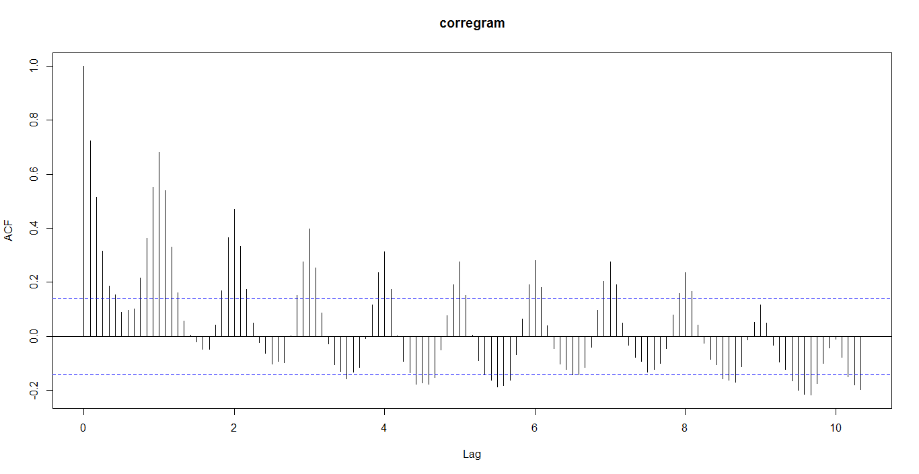
Decay is very slow, so non-stationary.
Hence we use first order difference of lag.
Corregram and partial Corregram of difference log transformed data:
> par(mfrow=c(1,2))
> acf(diff(log(UKDriverDeaths)), main="Corregram",lag.max=124)
> pacf(diff(log(UKDriverDeaths)),main="partial corregram",lag.max=124)

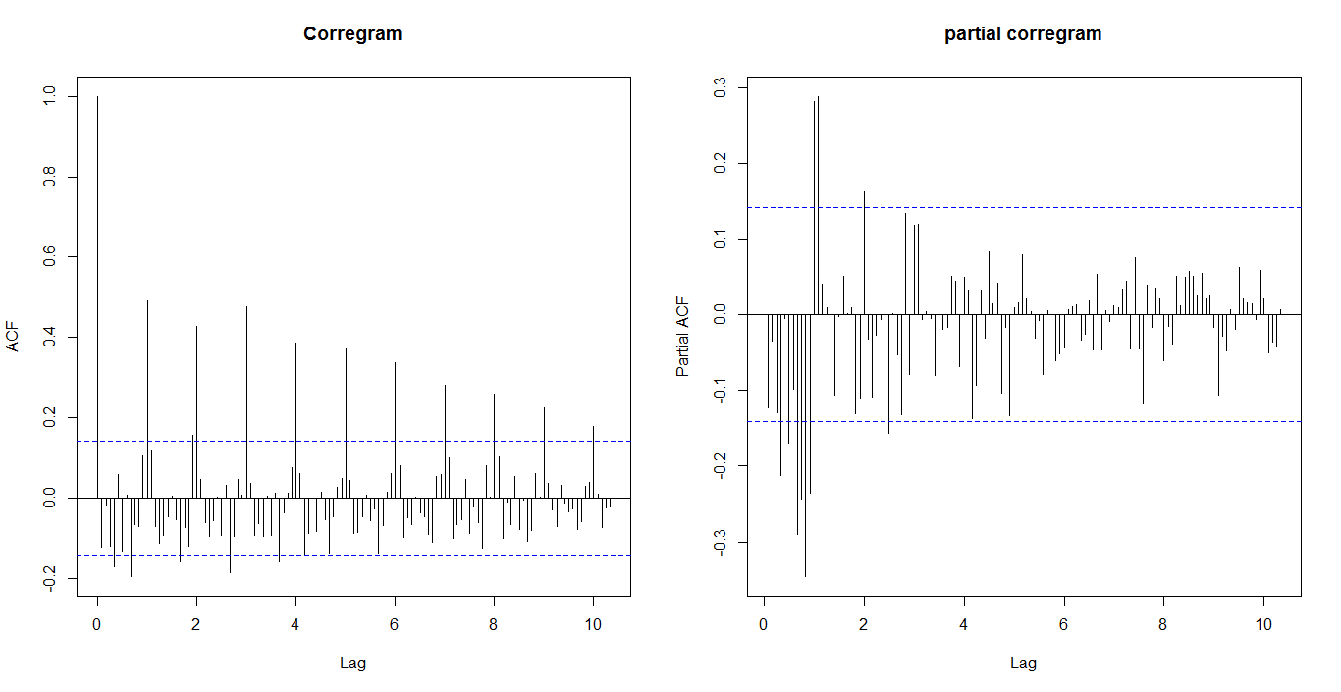

We have considered first order difference to remove trend and seasonality. Hence d=1,D=0
we examine at Lag 0,12,24,…
We have seen from the correlogram that the autocorrelation at lag 0, exceed the significance bound.
The partial correlogram shows that the partial autocorrelations at lags 2,exceed the significance bounds,
The partial autocorrelations tail off to zero after lag 1.
Similarly we examine between seasonal lag 1,2,1…12. And we get ,
We see from the correlogram that the autocorrelation at lag 1,2 ,exceed the significance bound.
The partial correlogram shows that the partial autocorrelations at lags1,exceed the significance bounds,
The partial autocorrelations tail off to zero after lag 1.
We use the principle of parsimony to decide which model is best: that is, we assume that the model with the fewest parameters is best. Hence ARIMA(1,1,0)X(2,0,0)₁₂ is best model

- Modeling the volatility:
Our next aim is to test does there any arch/garch effect or not for this we use Ljung–Box test

The test hypothesis for :Ljung-Box test:
i.e. series is suffered from arch/garch effect .
v/s
i.e. there is an arch/garch effect
Where:
- is the null hypothesis.
- is the alternate hypothesis.
- is the population autocorrelation function for the squared time series (i.e. ).
- is the maximum number of lags included in the ARCH effect test.

> Box.test(fit$residuals^2,lag=12,type="Ljung-Box")

Box-Ljung test

data: fit$residuals^2
X-squared = 6.2657, df = 12, p-value = 0.9021
Conclusion: As observed p-value of given test is greater than 5% l.o.s, so we fail to reject H₀. Hence there is no arch/garch effect.
Next step of Analysis is forecasting.
- Forecasting
Then we fit the SARIMA prediction model.
> fit=arima(log(UKDriverDeaths), c(1, 1, 0),seasonal = list(order = c(2, 0, 0), period = 12))
> fit

Call:
arima(x = log(UKDriverDeaths), order = c(1, 1, 0), seasonal = list(order = c(2,
0, 0), period = 12))

Coefficients:
ar1 sar1 sar2
-0.4363 0.4149 0.3669
s.e. 0.0667 0.0664 0.0715

sigma^2 estimated as 0.008674: log likelihood = 177.15, aic = -346.3
>

Then 95% C.I. for each prediction value is obtain and plot with observed value as fallow

> fore=predict(fit, n.ahead = 10*12)
> U=fore$pred + 2*fore$se # se: standard error (quantile is 2 as mean=0)
> L=fore$pred - 2*fore$se
> head(cbind(U,L))
U L
[1,] 7.498160 7.125618
[2,] 7.333926 6.906279
[3,] 7.468326 6.956666
[4,] 7.421780 6.852326
[5,] 7.536267 6.908815
[6,] 7.473282 6.795018
> # plot observed and predicted values
> ts.plot(UKDriverDeaths,2.718^fore$pred,2.718^U,2.718^L,log = "y", lty = c(1,1,2,2),col=c(1, 2, 4, 4))
> legend("topleft", c("Actual", "Forecast", "Error Bounds (95% prediction interval)"), col=c(1, 2, 4),lty=c(1, 1, 2),bty = "n")
>

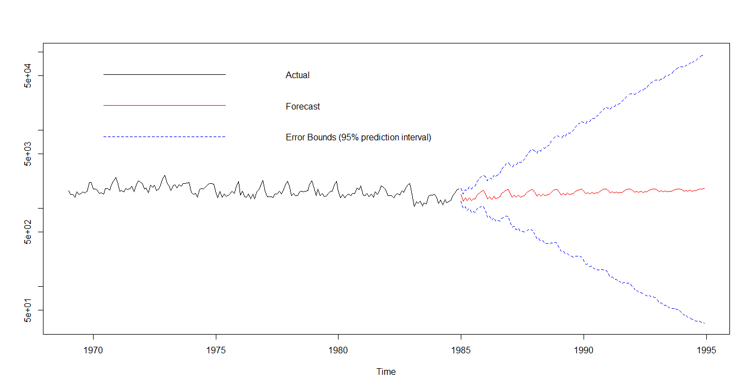

Last but not least step of analysis is assumption testing and cross verification.
- assumption testing and cross verification.
- Normality Testing
ARIMA fit the model using maximum likelihood estimation (assuming Gaussian residual).To check this assumption we use Q-Q plot.
> qqnorm(residuals(fit))
> qqline(residuals(fit))
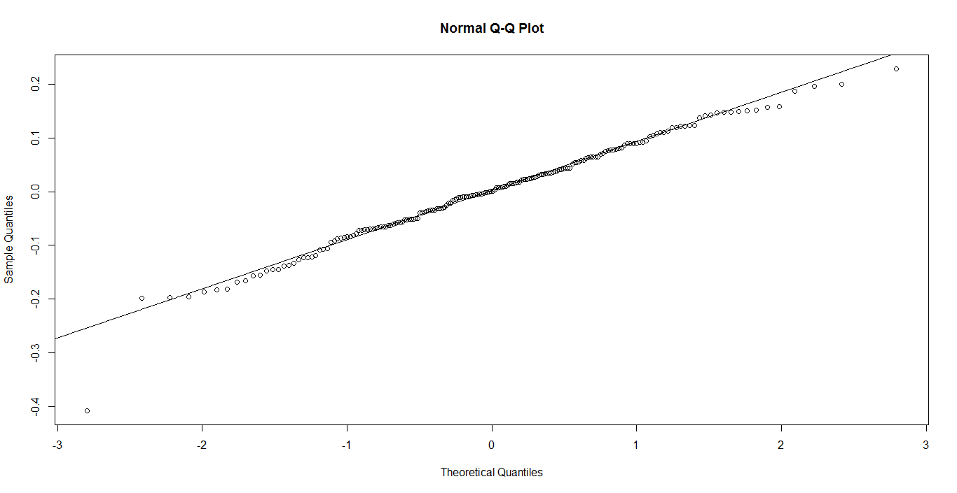
Conclusion: Linearity of point suggests that the distribution is normally distributed.

> shapiro.test(residuals(fit))

Shapiro-Wilk normality test

data: residuals(fit)
W = 0.98372, p-value = 0.02526

- Verifications of stationary
To cross check the stationary .we use Augmented Dickey-Fuller test.

> adf.test(residuals(fit), alternative="stationary", k=12)

Augmented Dickey-Fuller Test

data: residuals(fit)
Dickey-Fuller = -4.6976, Lag order = 12, p-value = 0.01
alternative hypothesis: stationary
Conclusion: Residuals are stationary.

Data set No.6
I have considered a data set USAccDeaths which is contained in R directories. A time series giving the monthly totals of
accidental deaths in the USA.

> data(USAccDeaths)
> d1=data.frame(time(USAccDeaths),USAccDeaths)
> summary(USAccDeaths)
Min. 1st Qu. Median Mean 3rd Qu. Max.
6892 8089 8728 8789 9323 11320
We have considered following step for analysis.
- Visualize the time series :
a)Time series plot:
> plot(USAccDeaths);abline(reg=lm(USAccDeaths~time(USAccDeaths))
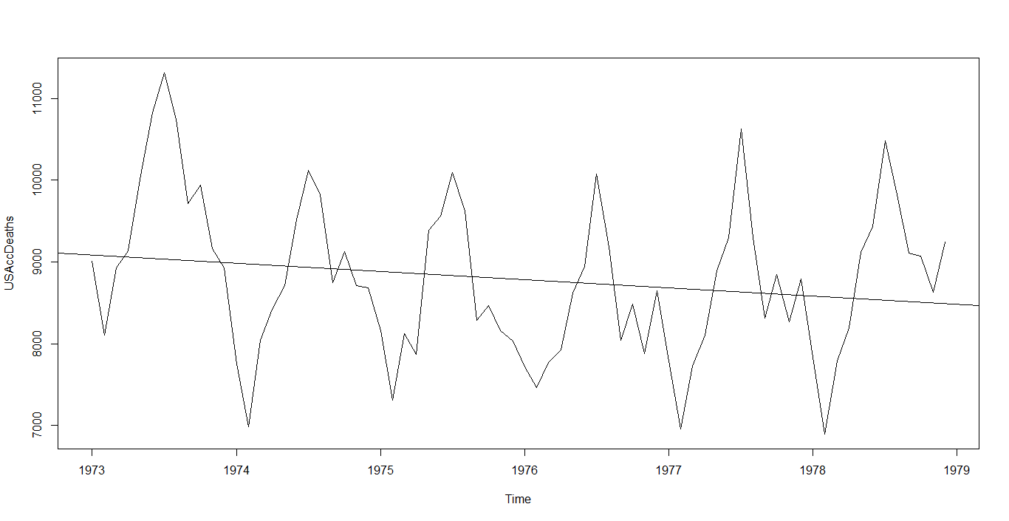
> boxplot(USAccDeaths~cycle(USAccDeaths))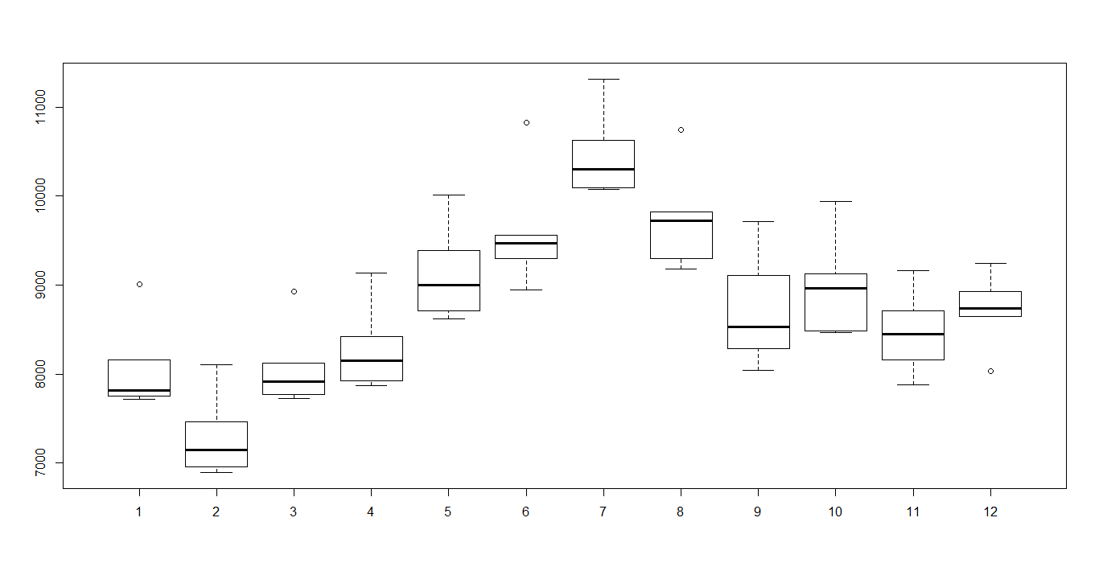

Interpretation:
. 1) The Year on year trend clearly shows that the number deaths have been decreasing .
- The variance and mean value in July and August is much higher than rest of months.
To remove unequal variance ,we use log –transformation .
3) There must be seasonal effect with cycle of 12 months.

b) Decompose seasonal data
A seasonal time series consists of a trend component, a seasonal component and an irregular component. Decomposing the time series means separating the time series into these three components: that is, estimating these three components.
> AP.decompM=decompose(USAccDeaths, type = "multiplicative")
> plot(AP.decompM)
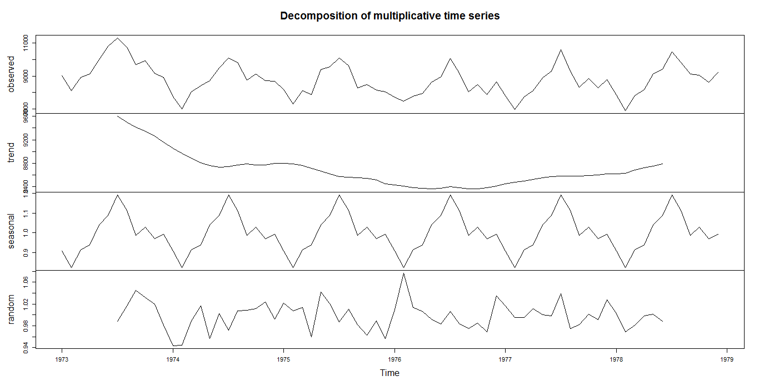
Interpretations:
The above figure shows the time series decomposition into trend, seasonal and random (noise) . It is clear that the time series is non-stationary (has random walks) because of seasonal effects and a trend (linear trend)
.
- Stationary the Series :
Our next test to test given series is stationary or not for this we use Augmented Dickey Fuller test the hypothesis of test

H_{o}: Unit root present in time series sample i.e. non-stationary. V/s
H₁: Time series sample is stationary.
> adf.test(log(USAccDeaths), alternative="stationary", k=12)

Augmented Dickey-Fuller Test

data: log(USAccDeaths)
Dickey-Fuller = -1.5898, Lag order = 12, p-value = 0.7423
alternative hypothesis: stationary

Conclusion: As observed p-value of given test is greater than 5% l.o.s, so we fail to reject H₀. Hence given series is non-stationary.
To make it stationary we have considered first order difference on Air passenger data. Then performed Augmented Dickey Fuller test.

> adf.test(diff(log(USAccDeaths)), alternative="stationary", k=10)

Augmented Dickey-Fuller Test

data: diff(log(USAccDeaths))
Dickey-Fuller = -10.957, Lag order = 10, p-value = 0.01
alternative hypothesis: stationary
As observed p-value of given test is less than 5% l.o.s, so we reject H₀. Hence given series is stationary.
The next step of analysis is to find optimal ARIMA Model through ACF and PACF.

- Plot ACF/PACF and find optimal parameter

- Corregram of Log transform data
> acf(log(USAccDeaths),lag.max=124,main="corregram")

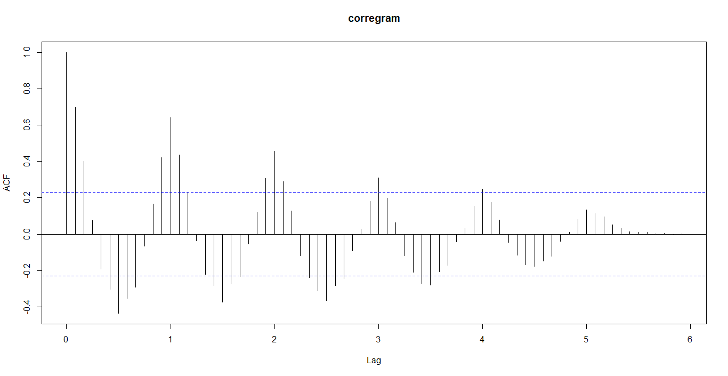
Conclusion:
Decay is very slow, so non-stationary.
Hence we use first order difference of lag.
Corregram and partial Corregram of difference log transformed data:
> par(mfrow=c(1,2))
> acf(diff(log(USAccDeaths)),main="Corregram",lag.max=124)
> pacf(diff(log(USAccDeaths)),main="partial corregram",lag.max=124)

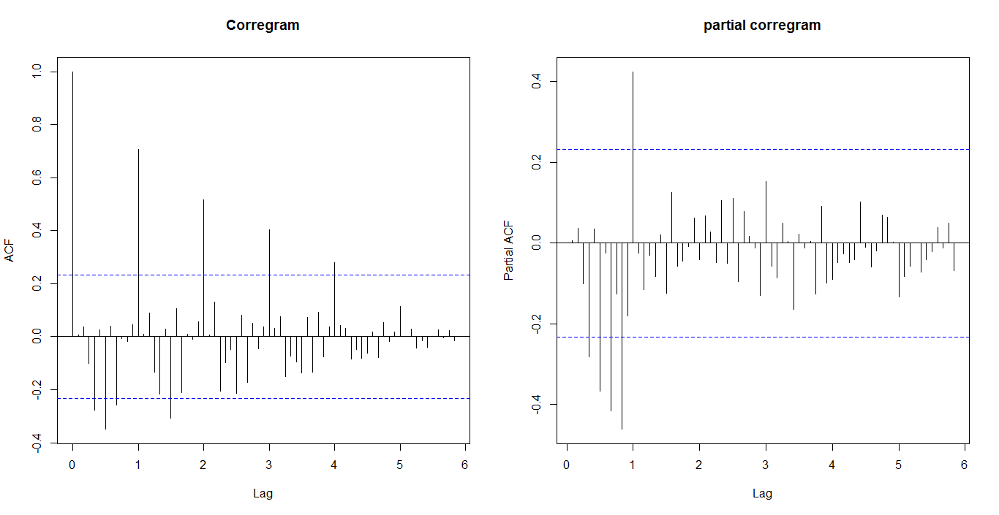
We have considered first order difference to remove trend and seasonality. Hence d=1,D=1
we examine at Lag 0,12,24,…
We have seen from the correlogram that the autocorrelation at lag 1,2, exceed the significance bound.
The partial correlogram shows that the partial autocorrelations at lags1,exceed the significance bounds,
The partial autocorrelations tail off to zero after lag 1.
Similarly we examine between seasonal lag 1,2,1…12. And we get ,
We see from the correlogram that the autocorrelation at lag 1,2 ,exceed the significance bound.
The partial correlogram shows that the partial autocorrelations at lags1,exceed the significance bounds,
The partial autocorrelations tail off to zero after lag 1.
We use the principle of parsimony to decide which model is best: that is, we assume that the model with the fewest parameters is best. Hence ARIMA(0,1,1)X(0,1,1)₁₂ is best model

- Modeling the volatility:
Our next aim is to test does there any arch/garch effect or not for this we use Ljung–Box test

The test hypothesis for :Ljung-Box test:
i.e. series is suffering arch/garch effect .
v/s
i.e. there is an arch/garch effect
Where:
- is the null hypothesis.
- is the alternate hypothesis.
- is the population autocorrelation function for the squared time series (i.e. ).
- is the maximum number of lags included in the ARCH effect test.

> Box.test(fit$residuals^2,lag=12,type="Ljung-Box")

Box-Ljung test

data: fit$residuals^2
X-squared = 19.152, df = 12, p-value = 0.08492
Conclusion: As observed p-value of given test is greater than 5% l.o.s, so we fail to reject H₀. Hence there is no arch/garch effect.
Next step of Analysis is forecasting.
- Forecasting
Then we fit the SARIMA prediction model
> fit=arima(log(USAccDeaths), c(0, 1, 1),seasonal = list(order = c(0, 1, 1), period = 12))
> fit

Call:
arima(x = log(USAccDeaths), order = c(0, 1, 1), seasonal = list(order = c(0,
1, 1), period = 12))

Coefficients:
ma1 sma1
-0.4713 -0.5926
s.e. 0.1230 0.1933

sigma^2 estimated as 0.001313: log likelihood = 109.31, aic = -212.63
Then 95% C.I. for each prediction value is obtain and plot with observed value as fallow
> fore=predict(fit, n.ahead = 10*12)
> U=fore$pred + 2*fore$se # se: standard error (quantile is 2 as mean=0)
> L=fore$pred - 2*fore$se
> head(cbind(U,L))
U L
[1,] 9.094755 8.949580
[2,] 8.997613 8.833428
[3,] 9.110663 8.929452
[4,] 9.154715 8.957945
[5,] 9.263088 9.051903
[6,] 9.310930 9.086253
> # plot observed and predicted values
> ts.plot(USAccDeaths,2.718^fore$pred,2.718^U,2.718^L,log = "y", lty = c(1,1,2,2),col=c(1, 2, 4, 4))
> legend("topleft", c("Actual", "Forecast", "Error Bounds (95% prediction interval)"), col=c(1, 2, 4),lty=c(1, 1, 2),bty = "n")

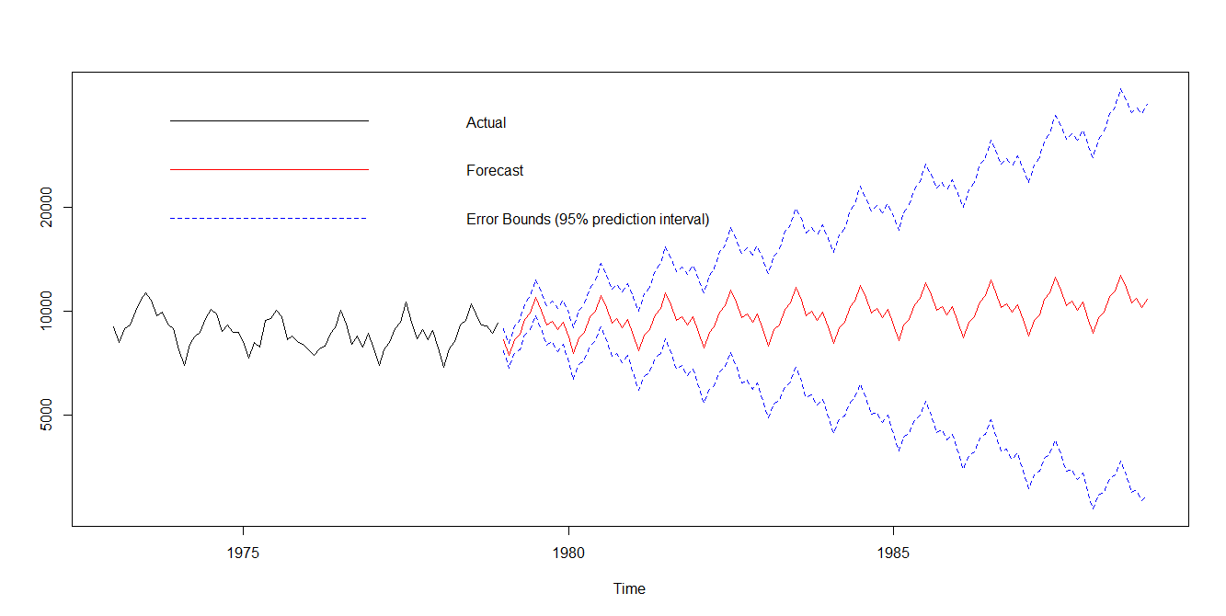
Last but not least step of analysis is assumption testing and cross verification.
- assumption testing and cross verification.
- Normality Testing
ARIMA fit the model using maximum likelihood estimation (assuming Gaussian residual).To check this assumption we use Q-Q plot.
> qqnorm(residuals(fit))
> qqline(residuals(fit))
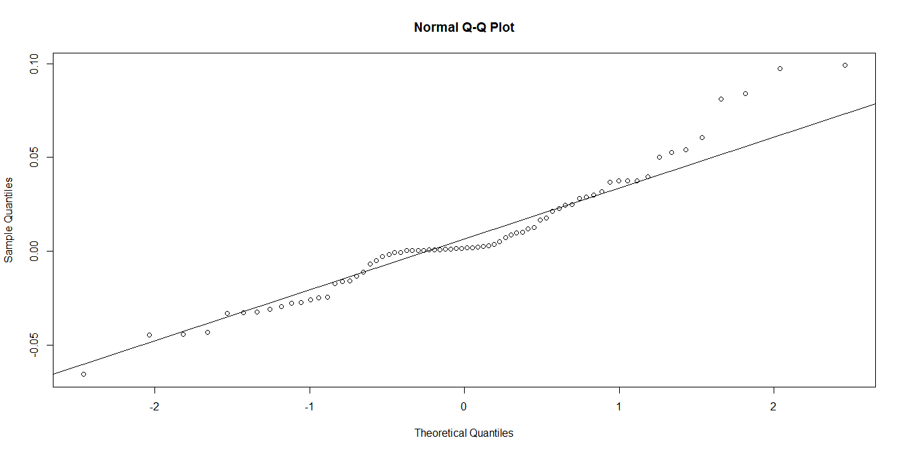
Conclusion: Linearity of point suggests that the distribution is normally distributed.

> shapiro.test(residuals(fit))

Shapiro-Wilk normality test

data: residuals(fit)
W = 0.95278, p-value = 0.08805

- Verifications of stationary
To cross check the stationary .we use Augmented Dickey-Fuller test.

> adf.test(residuals(fit), alternative="stationary", k=12)

Augmented Dickey-Fuller Test

data: residuals(fit)
Dickey-Fuller = -2.9519, Lag order = 12, p-value = 0.0018
alternative hypothesis: stationary
Conclusion: Residuals are stationary.

Data set No.7
Data description:
I have considered a data set treeing which is contained in R directories. Treeing contains year wise normalized treeing widths in dimensionless units from -6000 to 1979.
> d1=treering
> d1=ts(d1,end=c(1979))
> summary(d1)
Min. 1st Qu. Median Mean 3rd Qu. Max.
0.0000 0.8370 1.0340 0.9968 1.1970 1.9080
- Visualize the time series :
a)Time series plot:
> plot.ts(d1,type="o");abline(reg=lm(d1~time(d1)))

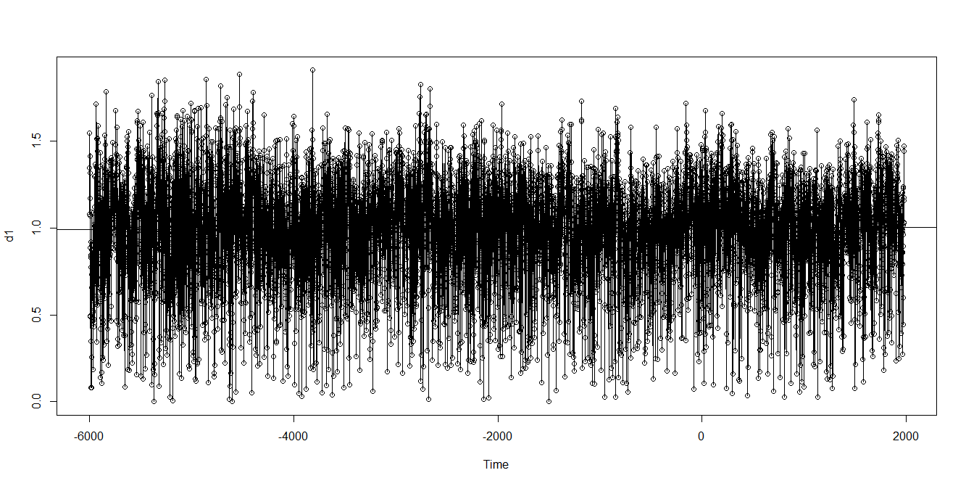
Interpretation:
.1) The Year on year trend clearly shows that the treeing have been constant.
- Time series plot doesn’t show seasonality pattern.

- We can see from the time plot that this time series could probably be described using an additive model, since the random fluctuations in the data are roughly constant in size over time.
- Forecasting
For short time forecast we can use exponential smoothing
> forecast=HoltWinters(d1,beta=FALSE,gamma=FALSE)
> forecast
all:
HoltWinters(x = d1, beta = FALSE, gamma = FALSE)

Smoothing parameters:
alpha: 0.08296874
beta : FALSE
gamma: FALSE

Coefficients:
[,1]
a 1.037181
The output of HoltWinters() tells us that the estimated value of the alpha parameter is about 0.104879. This is very
close to zero, telling us that the forecasts are based on both recent and less recent observations (although somewhat
more weight is placed on recent observations).
By default, HoltWinters() just makes forecasts for the same time period covered by our original time series.
> plot(forecast)

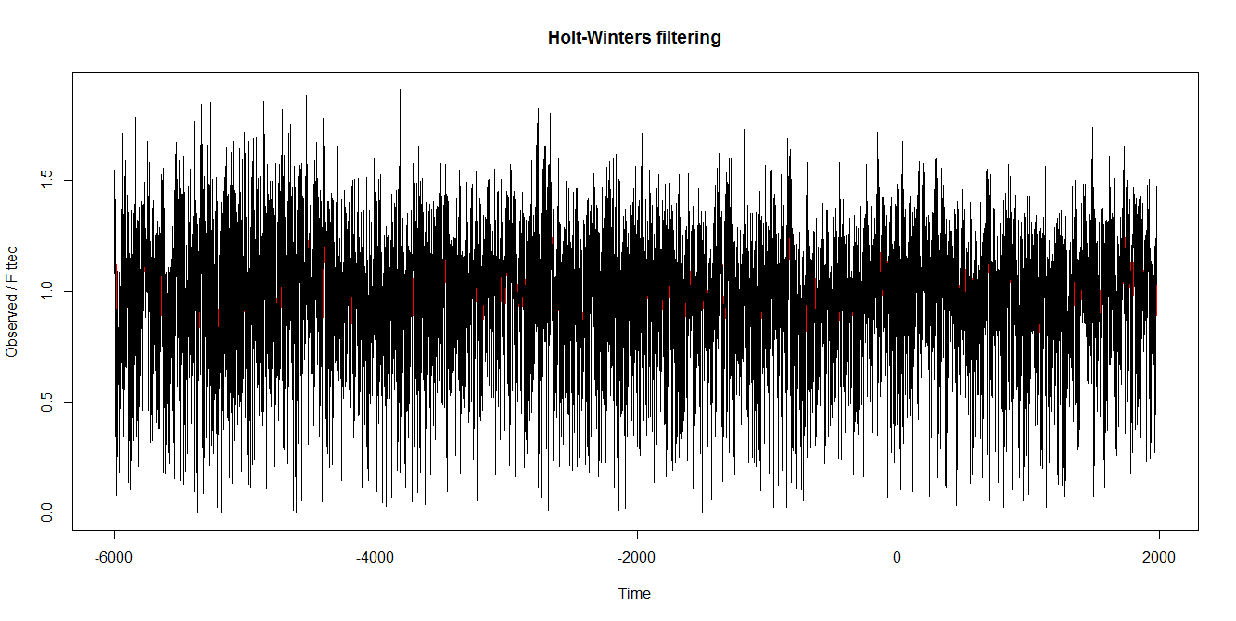

This is plot of original series and forecast series. Where red color shows forecasted series and black shows original series.
To check accuracy of forecasting we can sum of square of sample error.

> forecast$SSE
[1] 709.7225
We have forecast feather treeing from original series and plotted with original series as fallow

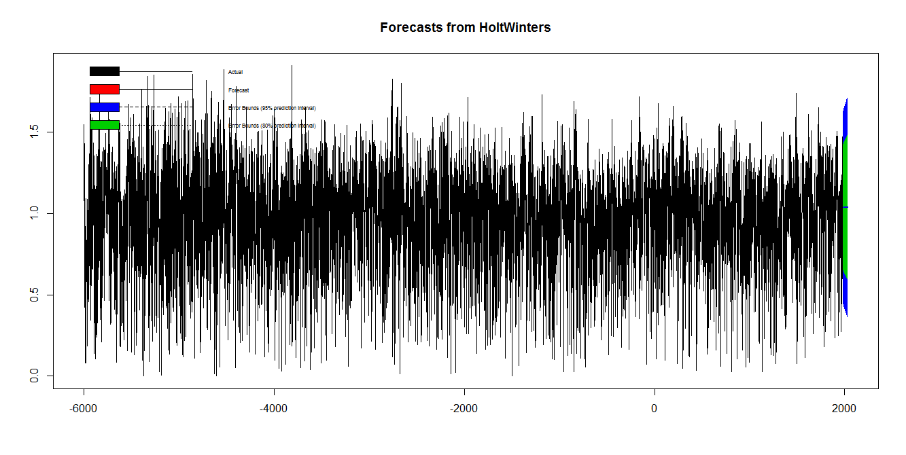

- Modeling of volatility
Our next aim is to test does there any arch/garch effect or not for this we use Ljung–Box test

The test hypothesis for :Ljung-Box test:
i.e. series is suffered from arch/garch effect .
v/s
i.e. there is an arch/garch effect
Where:
- is the null hypothesis.
- is the alternate hypothesis.
- is the population autocorrelation function for the squared time series (i.e. ).
- is the maximum number of lags included in the ARCH effect test.

> Box.test(forecast.HoltWinters(forecast,h= 55)$residuals^2,type="Ljung-Box")

Box-Ljung test

data: forecast.HoltWinters(forecast, h = 55)$residuals^2
X-squared = 12.229, df = 1, p-value = 4705
Conclusion: As observed p-value of given test is greater than 5% l.o.s, so we fail to reject H₀. Hence there is no arch/garch effect.
Next step of Analysis is forecasting.
- Assumption testing
We want to check weather residual fallow normality or not
> plotForecastErrors=function(forecasterrors)
+ {
+ mybinsize=IQR(forecasterrors)/4
+ mysd =sd(forecasterrors)
+ mymin= min(forecasterrors) - mysd*5
+ mymax = max(forecasterrors) + mysd*3
+ mynorm = rnorm(10000, mean=0, sd=mysd)
+ mymin2 = min(mynorm)
+ mymax2 = max(mynorm)
+ if (mymin2 < mymin) { mymin = mymin2 }
+ if (mymax2 > mymax) { mymax = mymax2 }
+ mybins = seq(mymin, mymax, mybinsize)
+ hist(forecasterrors, col="red", freq=FALSE, breaks=mybins)
+ myhist=hist(mynorm, plot=FALSE, breaks=mybins)
+ points(myhist$mids, myhist$density, type="l", col="blue", lwd=2)
+ }
> plotForecastErrors(fore$residuals[-1])
>

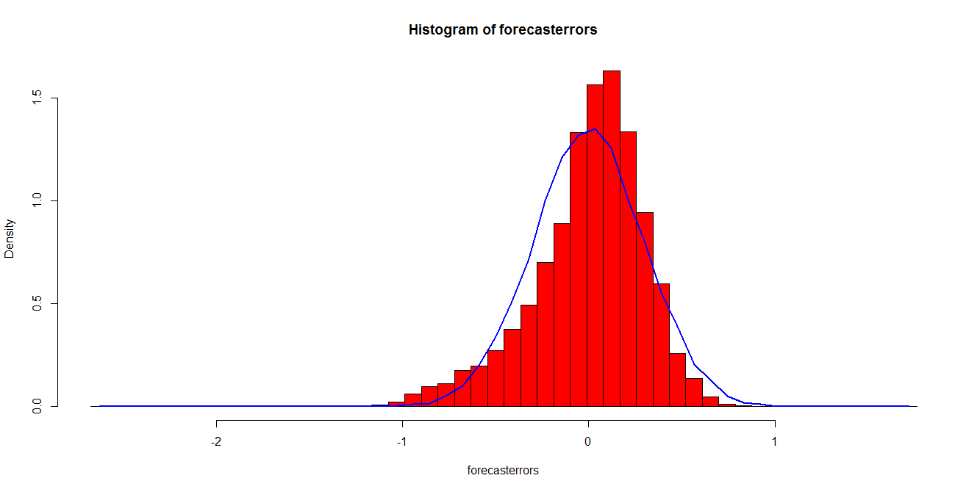
- The plot shows that the distribution of forecast errors is roughly centered on zero, and is more or less normally distributed, although it seems to be slightly skewed to the right compared to a normal curve. However, the right skew is relatively small, and so it is plausible that the forecast errors are normally distributed with mean zero. The Ljung-Box test showed that there is little evidence of non-zero autocorrelations in the in-sample forecasterrors, and the distribution of forecast errors seems to be normally distributed with mean zero. This suggests
that the simple exponential smoothing method provides an adequate predictive model for London rainfall, which probably cannot be improved upon. Furthermore, the assumptions that the 80% and 95% predictions intervals were based upon (that there are no autocorrelations in the forecast errors, and the forecast errors are normally distributed with mean zero and constant variance) are probably valid.

Data set No.8

Data Description:
I have considered a data set UKgas which is contained in R directories. Quarterly UK gas consumption from 1960Q1 to 1986Q4, in millions of therms.
> data(UKgas)
> summary(UKgas)
Min. 1st Qu. Median Mean 3rd Qu. Max.
84.8 153.3 220.9 337.6 469.9 1164.0

We have considered following step for analysis.
- Visualize the time series :
a)Time series plot:
> plot(UKgas);abline(reg=lm(UKgas~time(UKgas)))
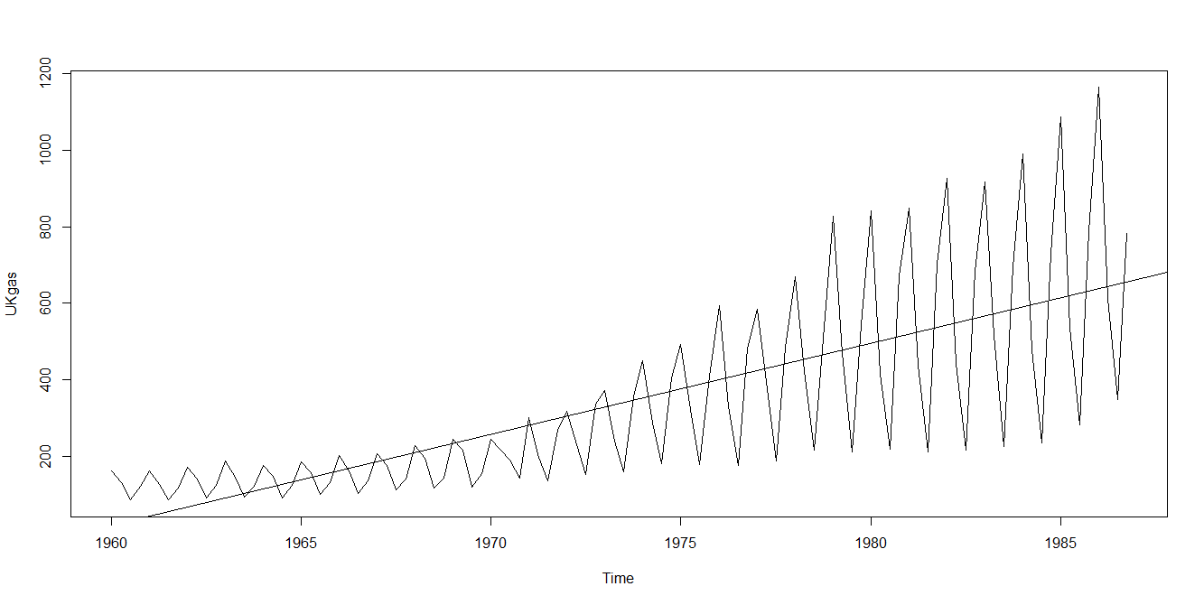
> boxplot(UKgas~cycle(UKgas))
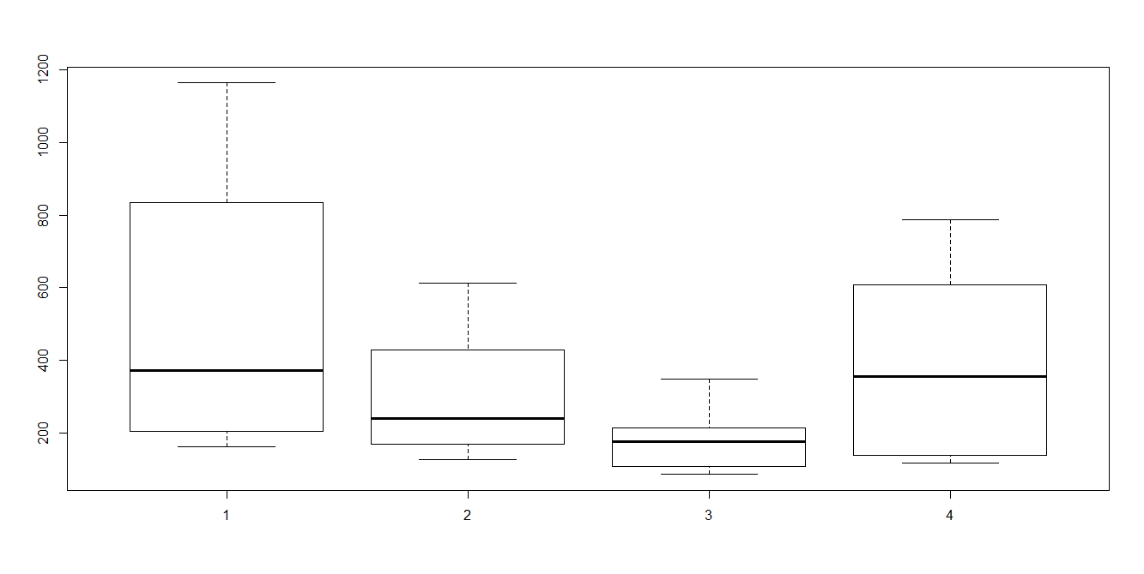

Interpretation:
. 1) The Year on year trend clearly shows that the gas consumption increasing .
- The variance and mean value in 1st and 2nd is much higher than rest of quarters.
To remove unequal variance ,we use log –transformation
3) There must be seasonal effect with cycle of 4 quarters.
b) Decompose seasonal data
A seasonal time series consists of a trend component, a seasonal component and an irregular component. Decomposing the time series means separating the time series into these three components: that is, estimating these three components.
> AP.decompM=decompose(UKgas, type = "multiplicative")
> plot(AP.decompM)

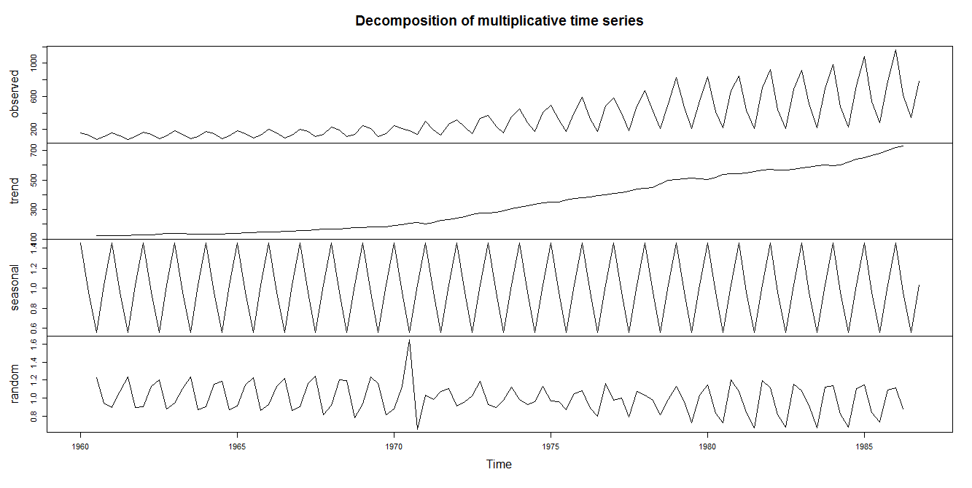
Interpretations:
The above figure shows the time series decomposition into trend, seasonal and random (noise) . It is clear that the time series is non-stationary (has random walks) because of seasonal effects and a trend (linear trend).
- Stationary the Series :
Our next test to test given series is stationary or not for this we use Augmented Dickey Fuller test the hypothesis of test

H_{o} : Unit root present in time series sample i.e. non-stationary. V/s
H₁: Time series sample is stationary.
> adf.test(log(UKgas), alternative="stationary", k=4)

Augmented Dickey-Fuller Test

data: log(UKgas)
Dickey-Fuller = -2.016, Lag order = 4, p-value = 0.57
alternative hypothesis: stationary

> adf.test(diff(log(UKgas)), alternative="stationary", k=4)

Augmented Dickey-Fuller Test

data: diff(log(UKgas))
Dickey-Fuller = -7.5123, Lag order = 4, p-value = 0.01
alternative hypothesis: stationary
> adf.test(log(UKgas), alternative="stationary", k=4)

Augmented Dickey-Fuller Test

data: log(UKgas)
Dickey-Fuller = -2.016, Lag order = 4, p-value = 0.57
alternative hypothesis: stationary

Conclusion: As observed p-value of given test is greater than 5% l.o.s, so we fail to reject H₀. Hence given series is non-stationary.
To make it stationary we have considered first order difference on Air passenger data. Then performed Augmented Dickey Fuller test .

> adf.test(diff(log(UKgas)), alternative="stationary", k=4)

Augmented Dickey-Fuller Test

data: diff(log(UKgas))
Dickey-Fuller = -7.5123, Lag order = 4, p-value = 0.01
alternative hypothesis: stationary

As observed p-value of given test is less than 5% l.o.s, so we reject H₀. Hence given series is stationary.
The next step of analysis is to find optimal ARIMA Model through ACF and PACF.

- Plot ACF/PACF and find optimal parameter

Corregram of Log transform data

> acf(log(UKgas),lag.max=124,main="corregram")

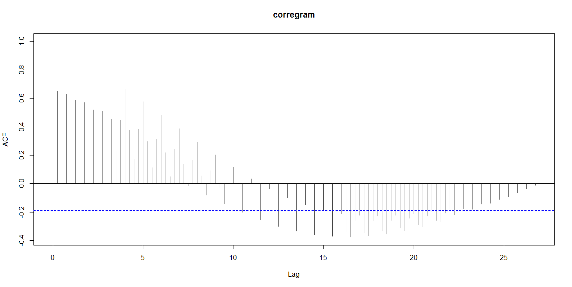

Conclusion:
Decay is very slow, so non-stationary.
Hence we use first order difference of lag.
Corregram and partial Corregram of difference log transformed data:

> acf(diff(log(UKgas)),main="Corregram")
> pacf(diff(log(UKgas)),main="partial corregram")
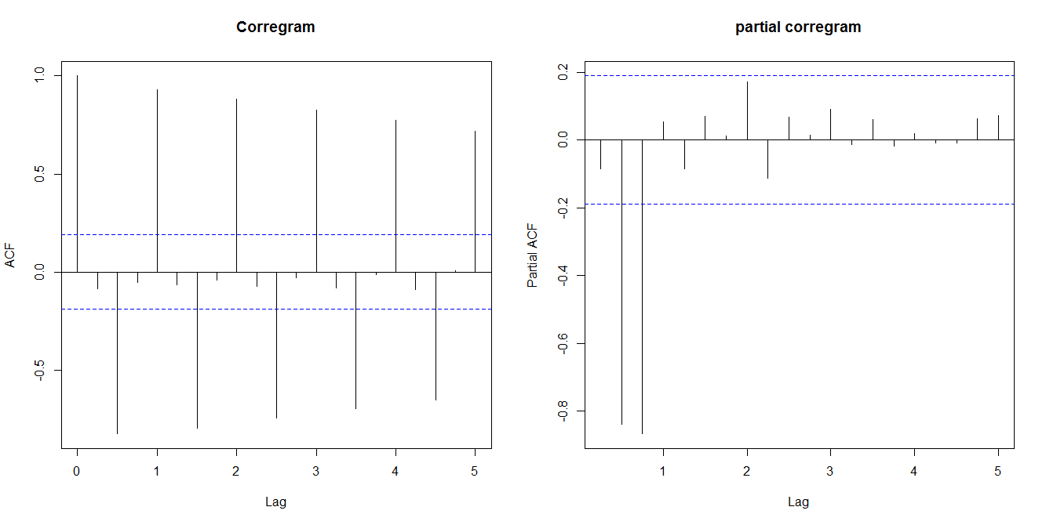

We have considered first order difference to remove trend and seasonality. Hence d=0,D=1
we examine at Lag 0,12,24,…
We have seen from the correlogram that the autocorrelation at lag 0, exceed the significance bound.
The partial correlogram shows that the partial autocorrelations at lags 0,exceed the significance bounds,
The partial autocorrelations tail off to zero after lag 0.
Similarly we examine between seasonal lag 1,2,1…12. And we get ,
We see from the correlogram that the autocorrelation at lag 1,2 ,exceed the significance bound.
The partial correlogram shows that the partial autocorrelations at lags1,exceed the significance bounds,
The partial autocorrelations tail off to zero after lag 0.
We use the principle of parsimony to decide which model is best: that is, we assume that the model with the fewest parameters is best. Hence ARIMA(0,0,0)X(0,1,0)₁₂ is best model

- Modeling the volatility:
Our next aim is to test does there any arch/garch effect or not for this we use Ljung–Box test

The test hypothesis for :Ljung-Box test:
i.e. series is suffered from arch/garch effect .
v/s
i.e. there is an arch/garch effect
Where:
- is the null hypothesis.
- is the alternate hypothesis.
- is the population autocorrelation function for the squared time series (i.e. ).
- is the maximum number of lags included in the ARCH effect test

> Box.test(fit$residuals^2,type="Ljung-Box")

Box-Ljung test

data: fit$residuals^2
X-squared = 2.2062, df = 1, p-value = 0.1375

Conclusion: As observed p-value of given test is greater than 5% l.o.s, so we fail to reject H₀. Hence there is no arch/garch effect.
Next step of Analysis is forecasting.
- Forecasting
Then we fit the SARIMA prediction model
> fit=arima(log(UKgas), c(0, 0,0),seasonal = list(order = c(0, 1,0), period = 4))
> fit

Call:
arima(x = log(UKgas), order = c(0, 0, 0), seasonal = list(order = c(0, 1, 0),
period = 4))

sigma^2 estimated as 0.01549: log likelihood = 69.16, aic = -136.31

Then 95% C.I. for each prediction value is obtain and plot with observed value as fallow
> U=fore$pred + 2*fore$se # se: standard error (quantile is 2 as mean=0)
> L=fore$pred - 2*fore$se
> head(cbind(U,L))
U L
[1,] 7.308417 6.810647
[2,] 6.667413 6.169643
[3,] 6.099362 5.601592
[4,] 6.911762 6.413992
[5,] 7.411508 6.707555
[6,] 6.770505 6.066552
> # plot observed and predicted values
> ts.plot(UKgas,2.718^fore$pred,2.718^U,2.718^L,log = "y", lty = c(1,1,2,2),col=c(1, 2, 4, 4))
> legend("topleft", c("Actual", "Forecast", "Error Bounds (95% prediction interval)"), col=c(1, 2, 4),lty=c(1, 1, 2),bty = "n")

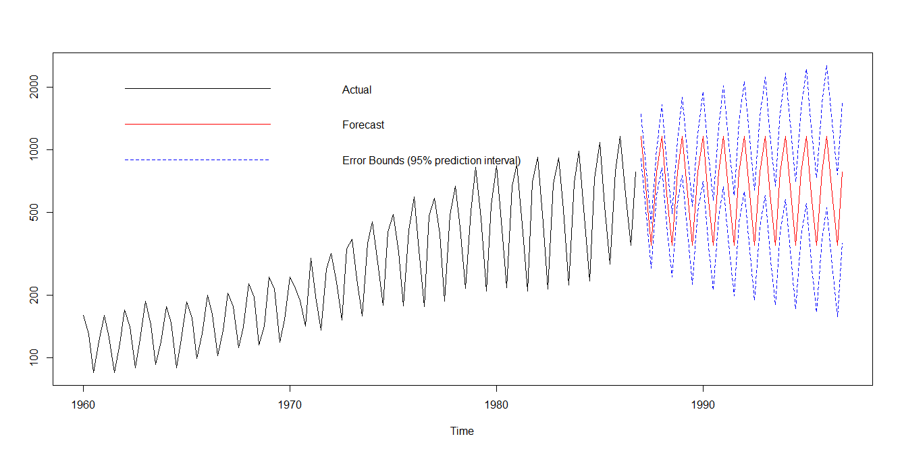
Last but not least step of analysis is assumption testing and cross verification.
- assumption testing and cross verification.
- Normality Testing
ARIMA fit the model using maximum likelihood estimation (assuming Gaussian residual).To check this assumption we use Q-Q plot.
> qqnorm(residuals(fit))
> qqline(residuals(fit))

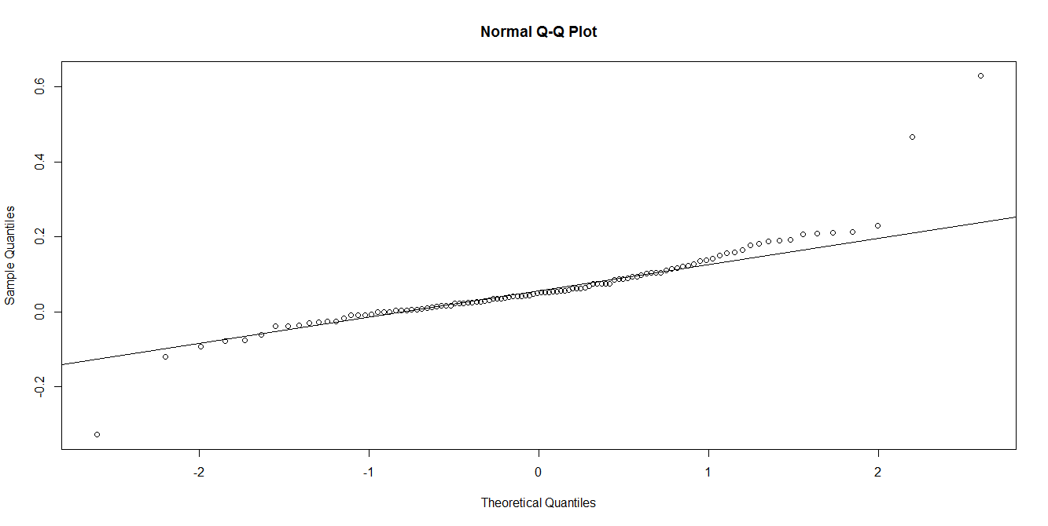
Conclusion: Linearity of point suggests that the distribution is normally distributed.

> shapiro.test(residuals(fit))

Shapiro-Wilk normality test

data: residuals(fit)
W = 0.83997, p-value = 0.0889

> adf.test(residuals(fit), alternative="stationary", k=12)

Augmented Dickey-Fuller Test

data: residuals(fit)
Dickey-Fuller = -1.5861, Lag order = 12, p-value = 0.0074
alternative hypothesis: stationary

Conclusion: Residuals are stationary and normally distributed.

